Fault Protection in a Component-Based Spacecraft Architecture

Elwin Ong, Nancy Leveson
MIT Aeronautics and Astronautics Dept.
elwino@mit.edu, leveson@mit.edu

Abstract:
As spacecraft become more complex and autonomous, the need for reliable fault protection will become more prevalent. When coupled with the additional requirement of limiting cost, the task of implementing fault protection on spacecraft becomes extremely challenging. The current state-of-the-art Cassini fault protection software, for example, is a testament to the complexity and difficulty of implementing fault protection on spacecraft. This paper describes how domain knowledge about spacecraft fault protection can be captured and stored in a reusable, component-based spacecraft architecture. The spacecraft-level fault protection strategy for a new spacecraft can then be created by composing generic component specifications, each with component-level fault protection included. The resulting fault protection design can be validated by formal analysis and simulation before any costly implementation begins. As spacecraft technology improves, new generic fault protection logic may be added, allowing active improvements to be made to the foundation.

Introduction

The use of a component-based spacecraft architecture has two potential advantages with respect to fault protection: the fault protection design can be integrated into the design of the rest of the software and critical domain knowledge can be captured and passed on.
Spacecraft science missions have traditionally been unique entities. The challenges of sending a probe to Saturn can be quite different from the challenges of rendezvousing with a comet. The uniqueness of each mission drives unique requirements for each spacecraft. These requirements in turn contribute to the diverse designs of spacecraft.
The unique design of each spacecraft is perhaps the single greatest challenge to developing cost-effective and reliable spacecraft fault protection software. Fault protection is system specific and traditionally cannot be designed or written until there is adequate information about the detailed spacecraft design. In addition, the process of designing a spacecraft is iterative, requiring many rounds of redesign: The design of the spacecraft in the initial design phases is likely to be very different from the final design. For this reason, fault protection software is often not implemented until the very end of the spacecraft design phase. This delay means that the fault protection software usually is developed as a separate and distinct entity from the rest of the spacecraft software design and by a separate group of engineers. These engineers may not have adequate first hand knowledge of the components for which they are designing the fault-protection, raising concerns about the correctness of the fault protection. Ideally, the engineers designing the Attitude Determination and Control Subsystem (ADCS), for example, should also design the fault protection software for the ADCS. This goal is difficult to achieve at the present time.
The second advantage of reusable architectural components is the ability to capture domain knowledge. Given the variety of spacecraft designs, the fundamental design principles of a spacecraft are and have remained relatively the same. All spacecraft share common requirements for power, attitude control, communication, etc. Furthermore, the technologies used to meet these requirements have also remained relatively static, a result of the high cost of space missions and the resulting risk-driven designs used to meet these requirements. As an example, the techniques and technologies used to perform attitude determination have been confined to a few varieties: inertial based (gyros), celestial vector referenced (sun sensors, star trackers, earth sensors), or magnetic field referenced (magnetometer). (The recent introduction of GPS based attitude determination can be regarded as a fundamentally new and unique technology)
This is not to say that the techniques and technologies used on spacecraft today are the same as those used on the first space missions. The field of spacecraft design has certainly evolved, but the underlying principles have remained the same. Each time a spacecraft is designed, engineers discover improvements that make the existing techniques more accurate or more robust. Like most engineering disciplines, spacecraft design is an evolutionary rather than a revolutionary process.
The knowledge required to design a complex system such as a spacecraft is extensive and much of it must be gained through experience. There are not many people who have the expertise to design and build a system that can travel in the harsh and relatively unknown environment of space, across vast distances measurable by the time traveled by light. The importance of capturing this expertise becomes ever more essential as the complexity of spacecraft increases and new engineers replace those who retire.
The primary goal of this research is part of a wider effort to capture, store, and ultimately reuse domain knowledge intrinsic to spacecraft fault protection and spacecraft design in general. Past attempts to reuse design have been at the implementation or code level, resulting in some spectacular losses (the Ariane 501 [4] and Mars Climate Orbiter [1]). This paper describes a new method of capturing and reusing spacecraft design, not at the implementation level but at the specification level, effectively creating a reusable spacecraft architecture. Specifications and models of components would be combined by the designer in a plug-and-play environment to create subsystems and ultimately a spacecraft design. Then changes would be made by the designers to tailor the component designs to the unique spacecraft requirements and the design validated using expert review, formal analysis, and simulation. Only after this system design validation is completed would implementation begin. MDS (Mission Data System), being developed at JPL, has similar goals but uses a different approach to achieving these goals. This paper illustrates the application of our approach to designing spacecraft fault protection. A description of the application of the approach to the design of spacecraft in general is beyond the scope of this paper and is described elsewhere [5].

Generic domain-specific specifications

To test the concept of a component-based spacecraft architecture with reusable specifications, a small library of reusable, generic spacecraft component specifications has been created using a specification methodology called Intent Specifications [3]. There are, for example, generic specifications of an Inertial Measuring Unit (IMU), Reaction Control System (RCS), Reaction Wheel Assembly System (RWA), Sun Sensor System (SS), and a Pressure Regulation System (PRS).
Each generic component specification describes the component’s hardware and software. Each component specification also includes generic fault protection features such as redundancy management. By specifying basic fault protection features for each generic component and building a complete spacecraft specification from these components, fault protection is included in the design of the spacecraft from the very beginning. Instead of being a separate entity that cannot be completed until a final spacecraft design has been completed, fault protection becomes an integral part of the general spacecraft design process. The design requirements for fault protection can be used to drive design decisions from the beginning of the spacecraft design process. In addition, the engineers designing a particular component or subsystem will be responsible for designing the fault protection at that component or subsystem level, thus guaranteeing that fault protection is designed by engineers with first hand knowledge of that part of the system.

Intent specifications

The success of this approach (and indeed any extensive reuse) depends on capturing the design rationale and assumptions upon which the reusable component designs rest. We accomplish this goal by using intent specifications [3]. While the concept of reusable specification is not specific to a particular specification methodology, there are many benefits to creating the reusable library using intent specifications. Intent specifications were designed to aid engineers in managing requirements, design, and evolution of complex systems and a toolset exists to support the methodology.
The features of intent specifications and the toolset (called SpecTRM) that are the most important in the context of our research are:
- Intent specifications enforce good documentation practices, and they provide a means to specify and easily link requirements, design rationale, and design assumptions. The links support traceability and the ability to find the places that need to be changed when instantiating the generic specifications.
- SpecTRM integrates the results of hazard analysis and other safety-related information into the engineering specifications, which aids in the design of fault protection mechanisms to mitigate the identified hazards.
- Intent specifications and SpecTRM include a formal modeling language called SpecTRM-RL, which allows users to formally model the blackbox behavior of the system. Having a formal model of the system allows for mathematical analyses and simulation of the system behavior before any costly code is implemented.

An example: Cassini PRS fault protection

To investigate the feasibility of our framework for reuse of fault protection design, a generic PRS specification was modified and combined with a generic ADCS subsystem specification to create a Cassini-like PRS fault protection specification [2].

Generic PRS and ADCS specification

The generic PRS specification is based on a design common to bipropellant propulsion systems. The system includes three tanks, one for the pressurizing gas, which is Helium in this case, and two for the propellants (oxidizer and fuel). Besides the tanks, all other components of the PRS are dual redundant. Passive pressure regulators regulate the flow of Helium into each propellant tank. Latch valves and pyrotechnic valves are designed to allow the system to reconfigure to a redundant branch should the primary branch fail. The generic PRS specification has one dual-string pressure transducer for each propellant tank. Cassini’s PRS includes an extra pressure transducer on the fuel tank. A block diagram of our simplified implementation of Cassini’s PRS is shown in the figure below.
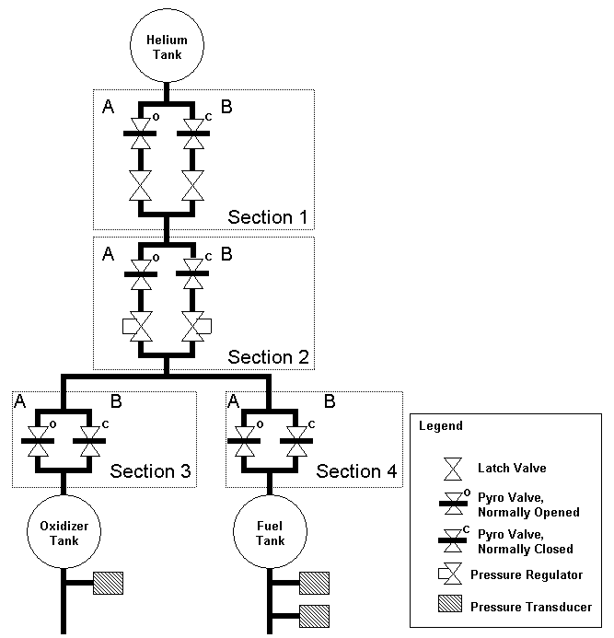
Figure 1 – Cassini PRS Block Diagram
The generic PRS specification is linked to a generic ADCS subsystem specification. The ADCS specification includes requirements and design principles associated with a typical ADCS subsystem. The ADCS specification is linked to other components specific to a particular spacecraft design such as Cassini. For space reasons, only the interface between the PRS and ADCS will be described in this paper.

  - Cassini fault protection software

Cassini’s fault protection software is a traditional monitor and response based algorithm. The PRS fault protection algorithms monitor telemetry from pressure transducers on each propellant tank and declare an overpressurization event if the telemetry exceeds predefined limits. Following the detection of an overpressurization event, the algorithm invokes a response, which sends predetermined commands to latch valves and pyrotechnic valves to cut off the flow of Helium into the propellant tanks.
There are two separate monitors and responses for the PRS. The design of each monitor is the same except for different overpressure limits. Each monitor checks the inputs from all three pressure transducers and declares an overpressurization event if inputs from two out of three pressure transducers are above the pressure limit.
Both responses are designed to cut off the flow of Helium through the prime regulator. The first response attempts to stem the flow through the prime regulator by closing the primary latch valve. The second response is designed to further isolate the prime regulator should the first response fail to stop the overpressurization event (the failure of the first response can result from the failure to command the latch valve or a failure of the latch valve itself). The second response initiates and engages pyrotechnic valves between the Helium tank and the prime regulator, permanently shutting the flow through the primary regulator.
Cassini’s overpressurization fault protection algorithms are part of the larger spacecraft-wide fault protection software. In addition to other subsystem-specific fault protection algorithms, the software contains responses for system-level faults or faults that affect the operation of the entire spacecraft such as loss of attitude. The scope of this paper is limited to the discussion of the component-level and subsystem-level fault protection.

- Specifying and modeling PRS fault protection using intent specifications

There are seven levels in an intent specification. Levels do not represent refinement, as in other more common hierarchical structures, but instead each level of an intent specification represents a complete and different view of the system [3]. Levels 1, 2, and 3 of intent specifications include the information generated during system engineering. The other levels of intent specifications describe component implementation details.
Level 1 of the intent specification for the PRS includes high-level system requirements. An example of a high-level requirement for the PRS is the following:
[FR.4] The PRS shall detect an overpressurization event in the oxidizer and fuel tank.
Figure 2 – PRS High Level Requirement
Level 1 also contains documentation on the hazard analysis and other safety-related system analyses and processes. As an example, the PRS hazard list includes the following items:
[HL.1] The oxidizer tank and fuel tank pressure is over 269 psia.
Rationale: The oxidizer tank and fuel tank is designed for a maximum pressure limit of 269 psia with a safety factor of 2. Overpressurization of either tank will lead to catastrophic failure of the tanks, causing possible rupture and eventual explosion. Any explosion onboard the spacecraft will likely result in the failure of the entire spacecraft.

[HL.2] Inadvertent engagement of pyrotechnic valve. Rationale: The pyrotechnic valve should only be engaged, either automatically by the fault protection software, or manually by ground controllers, when there are no other mechanisms available to stem an overpressurization event. [SC.4]
Figure 3 – PRS Hazard List
[SC.4] The pyrotechnic valves must not be engaged inadvertently. [HL.2]
SpecTRM provides engineers with the ability to easily create links between various elements in the specification. As an example, the hazard HL.2 can be traced to the safety design constraint SC.4 shown below, which in turn can point to the design features that implement this design constraint.
Figure 4 – PRS Safety Design Constraint
Level 2 of intent specifications contain the system design principles and features used to satisfy the requirements and constraints at Level 1. For the PRS fault protection algorithms, Level 2 describes the logic of the monitor and response design. An example of a design principle is shown in Figure 5.
Figure 5 – PRS Design Principle
[DP.3.4] Overpressurization fault protection algorithms declare an overpressurization event if two out of the three pressure transducers indicate an overpressure condition persistently for 5 seconds.
Rationale: The two out of three comparison prevents either an inadvertent response trip or a failure to detect an overpressure if there is a faulty pressure transducer. It also prevents an inadvertent response trip due to a thermally induced pressure condition in the oxidizer tank.
Rationale: The persistence condition prevents a transient condition from initiating the response.
Level 3 of an intent specification contains a formal blackbox model of the system behavior and a specification of the system interfaces. The PRS interfaces with various valves and pressure transducers as well as with the ADCS controller, which is also modeled. The input/output interfaces between the PRS and all external components are shown in Figure 6.
The externally observable behavior of the PRS fault protection software is modeled using a formal modeling language called SpecTRM-RL. The PRS model shown in Figure 6 contains a description of the component’s supervisory mode, control modes, and state variables.
The Supervisory Mode indicates the component currently supervising or controlling the system when there is a possibility of having more than one. The Supervisory Mode is explicitly modeled to help prevent mode confusion errors.
There are several control modes for the PRS (see Figures 1 and 6): Startup, Primary, Secondary, or Off Nominal. For example, if any part of the PRS is Off Nominal, then the overall control mode is also Off Nominal. The control mode of each fault protection algorithm is also specified as either Enabled or Disabled.

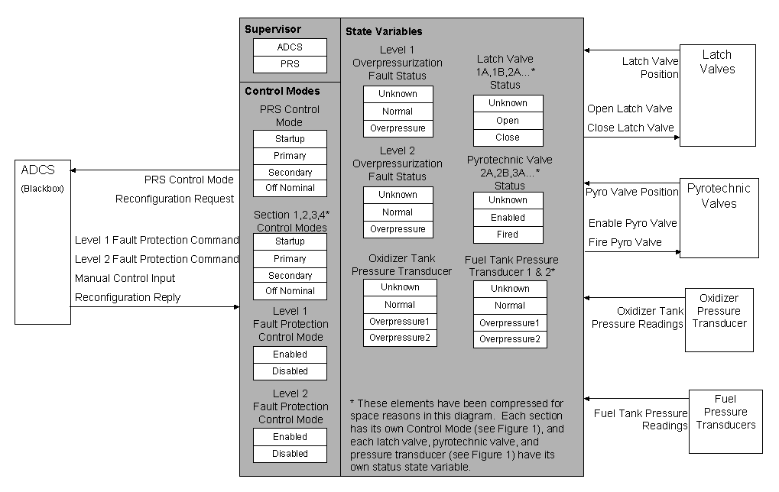
Figure 6 – PRS Blackbox Model

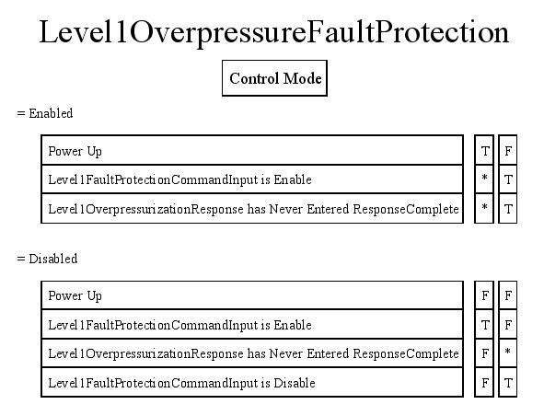
Figure 7 – SpecTRM-RL Control Mode
The Level 1 Overpressurization Fault Protection Control Mode logic using SpecTRM-RL logic tables (called AND/OR tables) is shown in Figure 7. The rows of the tables indicate AND relationships, while the columns represent ORs. An asterisk denotes a “don’t care” condition. If any of the columns evaluates to TRUE, then the control mode takes the value shown (Enabled or Disabled). For example, the Level 1 Overpressure Fault Protection Control Mode will transition to Enabled if the system is in Power Up (the system has just started) or the system is not in Power Up, but the component has received a command to enable fault protection AND the Level 1 Overpressurization Response has never been executed (the fault response is designed to execute only once after which the response is disabled).
State variables are used to model the controller’s current representation of the plant or controlled system. Examples of state variables in the PRS blackbox model include the status of each valve and the inferred pressure states in each propellant tank, which are based on inputs from the pressure transducers.
The logic for when state variables take particular values are also described with an AND/OR table. The following is a description of the logic for determining a Level 1 overpressurization:

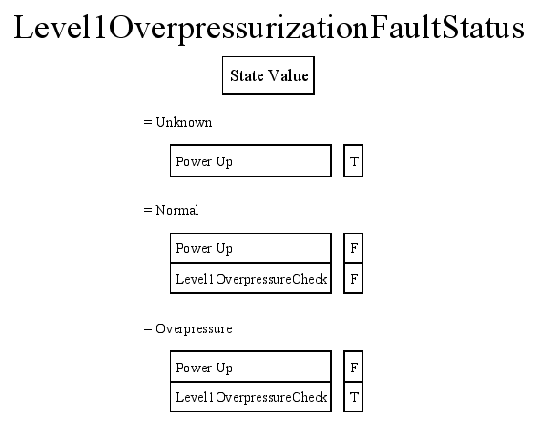
Figure 8 – SpecTRM-RL State Variable
As specified in Level 2 (Figure 5), the design principle of declaring overpressurization requires 2 of the 3 pressure transducers to be over the overpressure limit. This logical construct is implemented by the state variable represented in Figure 8. The current value of the Level 1 Overpressurization Fault Status depends on the value of the Level 1 Overpressurization Check, which is defined as a macro and shown in Figure 9. Macros are simply separate AND/OR tables designed to manage the complexity of the specification.

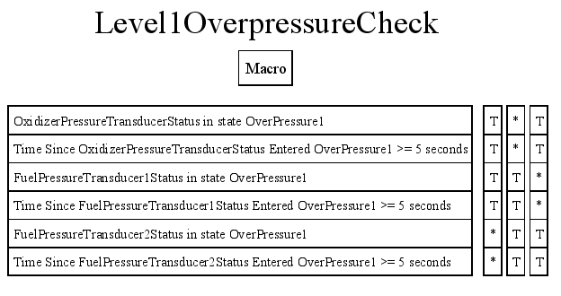
Figure 9 – SpecTRM-RL Macro

Analysis

The power of having a formal model of the specification is that it enables engineers to run mathematical analyses. SpecTRM currently has two analysis tools available. The first checks for non-determinism, i.e., whether there is more than one transition possible for a state or mode value given a set of inputs. If there are non-deterministic state or mode values in the model, the design of the system is inconsistent and probably needs to be modified.
The second analysis, called robustness, checks that for a given set of inputs, there is at least one transition available for a state or mode value, that is, that the specification of the behavior is logically complete.

Simulation

Perhaps the biggest benefit of a having a formal model is that it allows engineers to simulate the specified system behavior. The behavior of the system may be viewed and tested at an early stage in the design process, before any code is written. Multiple formal specifications may be linked and simulated using SpecTRM. An entire formal spacecraft subsystem specification such as the ADCS, which is created by linking specifications of individual components such as a PRS, RCS, IMU, and Star Tracker, may also be simulated using the SpecTRM toolset.
Simulations of the specification can be extremely useful as designs are often changed in the early phases of the development process. By combining various generic components, the simulated interactions between components can be analyzed as the design evolves. In the context of fault protection, because each generic component specification includes component level fault protection, the subsystem fault protection software can be derived from the combination of the various components. SpecTRM also allows users to inject faults from various external components during simulation to determine the response of the specified fault protection design.

6. Discussion and Conclusions

The success of a generic domain-specific specification architecture relies on two qualities: the first is the ease with which each generic specification may be modified for a specific design. Starting from a generic PRS specification, it took one graduate student about a day to modify the generic specification to match Cassini’s fault protection design. Although the initial generic PRS was based on a simplified version of Cassini’s PRS, the time scale for creating the specification is still less than the time it would have taken to build a specification from scratch.
The second challenge is scalability. So far, we have only created specifications for a single subsystem, but in a real spacecraft, much of the fault protection software is spacecraft-wide. A failure in the PRS affects the ADCS, for example, but in order to reconfigure the system, the spacecraft must ensure that there is enough power to carry out the reconfiguration procedures. For a typical spacecraft, this entails shutting down all nonessential components. We are extending our example spacecraft architecture to evaluate the feasibility of applying our approach to the interactions between subsystems, such as the ADCS and Power subsystems.
Finally, there is a fundamental difference between the implementation of Cassini’s fault protection software using the component-based specification reuse framework outlined in this paper and Cassini’s actual fault protection software. In Cassini, the fault protection software is implemented as an independent entity, separate from the spacecraft’s individual subsystem software. Our implementation, in contrast, encapsulates fault protection software within each subsystem specification. There are distinct advantages and disadvantages associated with each architecture. Future research will involve a formal examination and comparison of our framework with current spacecraft development processes.

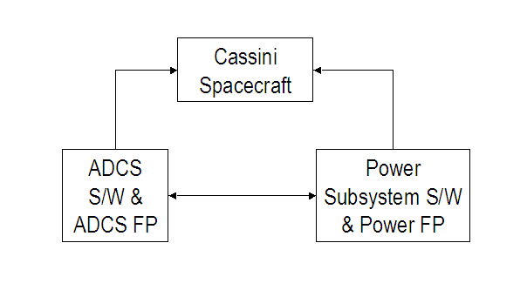
Figure 10 – Cassini Software using our component-based spacecraft architecture

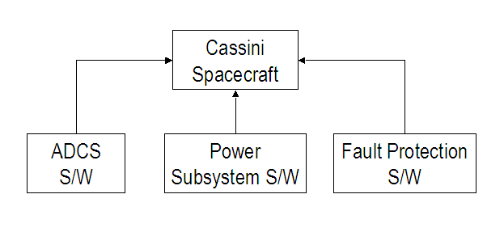
Figure 11 – Cassini’s Actual Software Architecture

Acknowledgement

This research in this paper was partially supported by NSF ITR Grant CCR-0085829, and by NASA Engineering for Complex Systems Program grant NAG2-1543.

7. References

- Euler, E.E., Jolly, S.D., and Curtis, H.H. “The Failures of the Mars Climate Orbiter and Mars Polar Lander: A Perspective from the People Involved”. Guidance and Control 2001, American Astronautical Society, paper AAS 01-074, 2001.

- Jet Propulsion Laboratory, Cassini Orbiter Functional Requirements Book System Fault Protection Algorithms Rev A., Aug. 1997.

- Leveson, Nancy G., “Intent Specifications: An Approach to Building Human-Centered Specifications”, IEEE Transactions on Software Engineering, Jan. 2000.

- Lions, J.L “Ariane 501 Failure: Report by the Inquiry Board”. European Space Agency, 19 Jul. 1996.

- Weiss, K.A., “"Building a Reusable Spacecraft Architecture using Component-Based System Engineering", Masters Thesis, Aeronautics and Astronautics Dept., MIT, 2003.

