A New Approach to Hazard Analysis for Complex Systems

Nancy G. Leveson, Ph.D.; Massachusetts Institute of Technology, Cambridge, MA

Abstract

Last year, a new accident model called STAMP (Systems-Theoretic Accident Modeling and Process) was presented at this conference (ref. 1). The model is based on systems theory as opposed to traditional failure-event models. Traditional models do a poor job of handing systems containing software and complex human decision making; the organizational and managerial aspects of systems, e.g., the safety culture and management decisions; and the adaptation of systems over time (migration toward hazardous states). This paper briefly describes STAMP and shows how it can be used to create a new approach to hazard analysis.

Introduction

Most hazard analysis techniques focus on failure events. In these event-based techniques, hazard analysis consists of identifying the failure events that can lead to a hazard, usually putting them into event chains or trees. Two popular techniques to accomplish this are Fault Tree Analysis (FTA) and Failure Modes and Effects Criticality Analysis (FMECA). Because of their basic dependence on failure events, neither does a good job of handling software or system accidents where the losses stem from dysfunctional interactions among operating components rather than failure of individual components.

In STAMP, the cause of an accident, instead of being understood in terms of a series of failure events, is viewed as the result of a lack of constraints imposed on system design and operations. The role of the system safety engineer in this model is to identify the design constraints necessary to maintain safety and to ensure that the system design and operation enforces these constraints. This view is closer to the classic system safety approach than the more reliability-oriented models often applied today.

A second paper last year described how STAMP could be applied in accident analysis using as an example a friendly fire shootdown over the Iraqi No-Fly-Zone (ref. 2). Since that time, we have also applied STAMP to a water contamination accident in Canada (ref. 3).

The new accident model is useful not only in analyzing accidents that have occurred but in developing system engineering methodologies to prevent accidents and that is the focus of this paper. Hazard analysis can be thought of as investigating an accident before it occurs. This paper describes a new hazard analysis technique, based on STAMP, that goes beyond component failure and is more effective than current techniques in protecting against system accidents, accidents related to the use of software, accidents involving cognitively complex human activities, and accidents related to managerial, organizational, or societal factors. The analysis starts with identifying the constraints required to maintain safety and then goes on to assist in providing the information and documentation necessary for system engineers and system safety engineers to ensure the constraints are enforced in system design, development, manufacturing and operations. A structured method for handling hazards during development, i.e., designing for safety, and during operations is presented.

This paper briefly describes STAMP and then presents a straightforward application of the model to hazard analysis. More sophisticated hazard analysis methods based on STAMP will be developed in the future.

A Brief Description of STAMP

In STAMP, accidents are conceived as resulting not from component failures, but from inadequate control or enforcement of safety-related constraints on the development, design, and operation of the system. The most basic concept in STAMP is not an event, but a constraint. Safety is viewed as a control problem: accidents occur when component failures, external disturbances, and/or dysfunctional interactions among system components are not adequately handled.

In the Space Shuttle Challenger accident, for example, the O-rings did not adequately control propellant gas release by sealing a tiny gap in the field joint. In the Mars Polar Lander loss, the software did not adequately control the descent speed of the spacecraft⎯it misinterpreted noise from a Hall effect sensor as an indication the spacecraft had reached the surface of the planet.

While events reflect the effects of component failures, dysfunctional interactions and inadequate enforcement of safety constraints, the inadequate control itself is only indirectly reflected by the events⎯the events are the result of the inadequate control. The control structure itself, therefore, must be examined to determine why the controls were inadequate to maintain the constraints on safe behavior and why the events occurred⎯for example, why the hot air gases were not controlled by the O-rings in the Challenger field joints, why the designers arrived at an unsafe design, and why management decisions were made to launch despite warnings that it might not be safe to do so.

Preventing accidents requires designing a control structure encompassing the entire socio-technical system that will enforce the necessary constraints on system development and operations.

Systems are viewed, in this approach, as interrelated components that are kept in a state of dynamic equilibrium by feedback loops of information and control. A system is not treated as a static design, but as a dynamic process that is continually adapting to achieve its ends and to react to changes in itself and its environment. The original design must not only enforce appropriate constraints on behavior to ensure safe operation, but it must continue to operate safely as changes and adaptations occur over time.

Instead of viewing accidents as the result of an initiating (root cause) event in a series of events leading to a loss, accidents are viewed as resulting from interactions among components that violate the system safety constraints. The control processes that enforce these constraints must limit system behavior to the safe changes and adaptations implied by the constraints.

Most hazard analyses (with the exception of HAZOP) are performed on system models contained only in the minds of the analysts. In contrast, hazard analyses based on STAMP use concrete models of the process. The HAZOP process has some similarities with STAMP hazard analysis, but HAZOP employs physical piping and wiring diagrams (the physical structure) whereas STAMP hazard analysis uses functional control models. In addition, HAZOP uses a set of keywords rather than being based on identified hazards. Finally, HAZOP is based on a model of accidents that views the causes as deviations in system variables whereas STAMP uses a more general model of inadequate control.
Any controller⎯human or automated⎯must contain a model of the system being controlled (ref. 2). The figure below shows a typical control loop where an automated controller is supervised by a human controller.
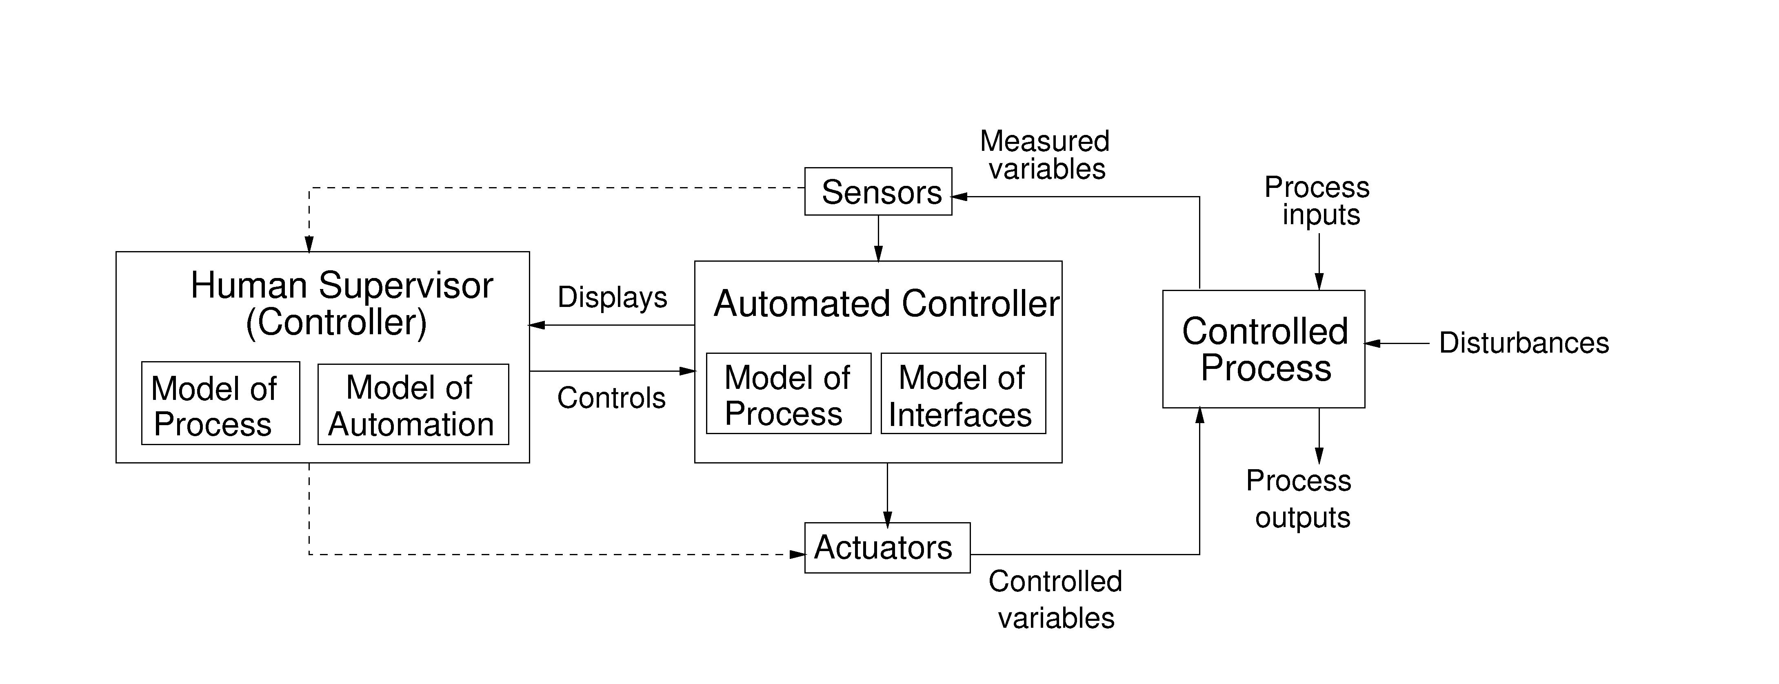
Figure 1: A Typical Process Control Loop

The model of the process (the plant, in control theory terminology) at one extreme may contain only one or two variables (such as that required for a simple thermostat) while at the other extreme it may require a complex model with a large number of state variables and transitions (such as that needed for air traffic control). Whether the model is embedded in the control logic of an automated controller or in the mental model of a human controller, it must contain the same type of information: the required relationship among the system variables (the control laws), the current state (the current values of the system variables), and the ways the process can change state. This model is used to determine what control actions are needed, and it is updated through various forms of feedback. When the model does not match the controlled process, accidents can result.

Accidents, particularly system accidents, often result from inconsistencies between the model of the process used by the controllers (both human and automated) and the actual process state: for example, the software does not know that the plane is on the ground and raises the landing gear or the pilot does not identify an object as friendly and shoots a missile at it, or the pilot thinks the aircraft controls are in speed mode but the computer has changed the mode to open descent and the pilot issues inappropriate commands for that mode. All of these examples have been involved in accidents.

System accidents may also involve inadequate coordination among several controllers and decision makers, including unexpected side effects of decisions or actions or conflicting control actions. Communication flaws play an important role here. Accidents are most likely in boundary areas or in overlap areas of control (see Figure 2).

When controlling boundary areas, there can be confusion over who is actually in control (which control loop is currently exercising control over the process), leading to omitted control actions. The functions in the boundary areas are often poorly defined. A factor in the loss of the Black Hawk helicopters to friendly fire over northern Iraq in 1994, for example, was that the helicopters normally flew only in the boundary areas of the No-Fly-Zone, and procedures for handling aircraft in those areas were ill defined.

Overlap areas exist when a function is achieved by the cooperation of two controllers or when two controllers exert influence on the same object. Such overlap creates the potential for conflicting control actions.

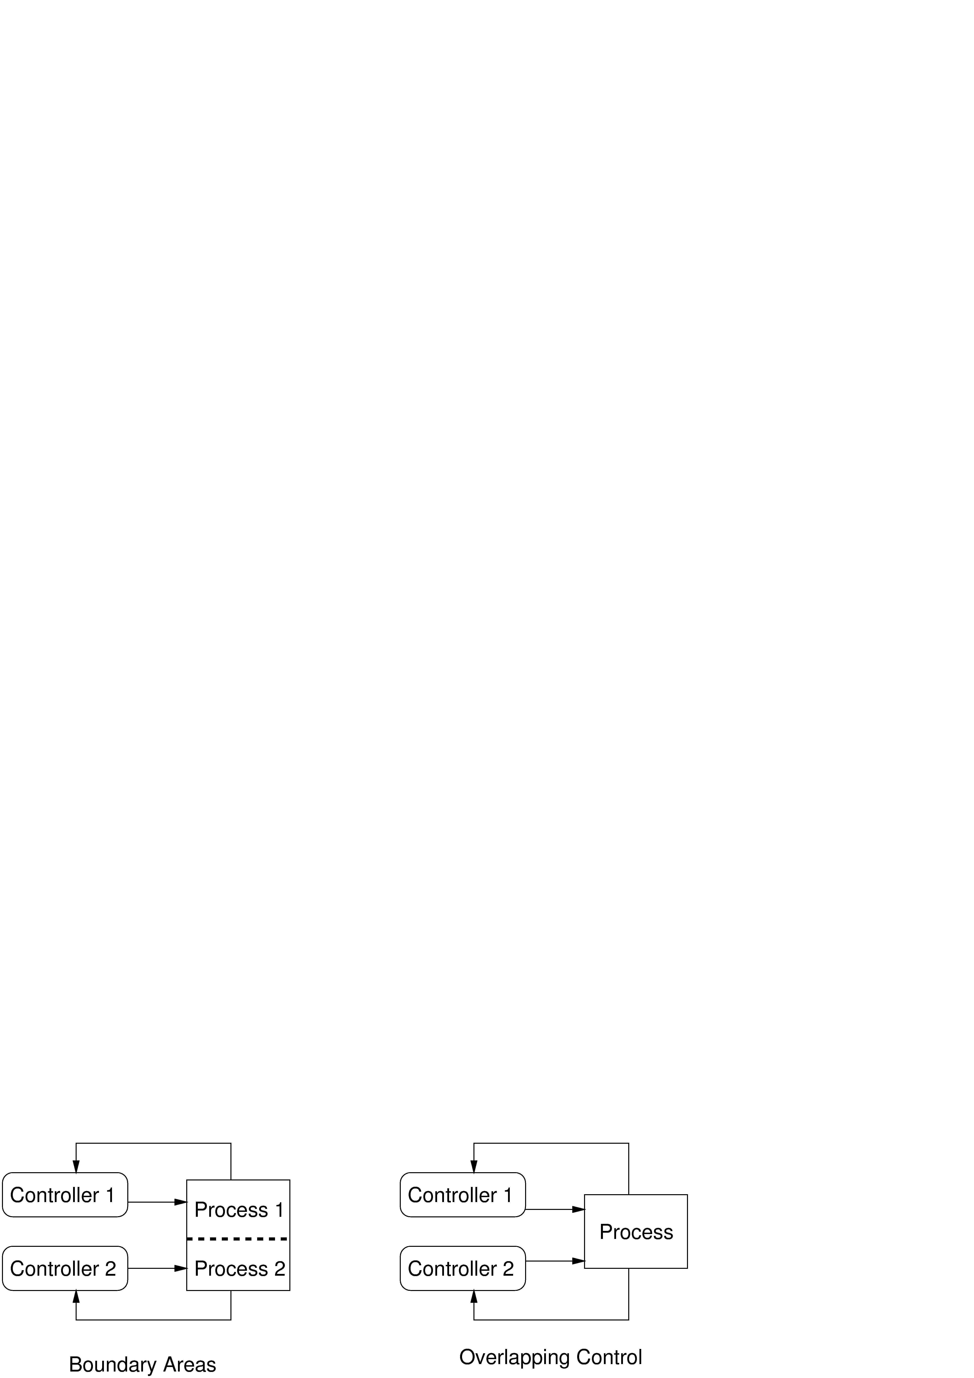

Figure 2 – Two Types of Designs with Potential for Coordination Problems

In both boundary and overlap areas, the potential for ambiguity and for conflicts among independently made decisions exists.

STAMP Hazard Analysis

A STAMP hazard analysis has the same general goals as any hazard analysis: (1) identification of the system hazards and the safety constraints necessary to ensure acceptable risk and (2) accumulation of information about how those constraints could be violated to use for eliminating, reducing, and controlling hazards in the system design and operations. TCAS II, an airborne collision avoidance system for commercial aircraft, is used as an example in this paper.

TCAS has several hazards, including:
- TCAS causes or contributes to a near midair collision (NMAC) defined as a pair of controlled aircraft violating minimum separation standards.
- TCAS causes or contributes to a controlled maneuver into the ground.
- TCAS causes or contributes to the pilot losing control of the aircraft.
- TCAS interferes with other safety-related aircraft systems.
- TCAS interferes with the ground-based Air Traffic Control system (e.g., transponder transmissions to the ground or radar or radio services).
- TCAS interferes with an ATC advisory that is safety-related, (e.g., avoiding a restricted area or adverse weather conditions)

Once the system hazards are identified, as in any system safety process, the system-level safety-related requirements and constraints must be identified, e.g., TCAS must not disrupt the pilot of ATC operations during critical phases of flight nor disrupt routine aircraft operations and Aircraft trajectory crossing maneuvers must be avoided if possible. The STAMP hazard analysis uses these system-level requirements and constraints, and as the STAMP analysis progresses, new requirements and constraints will be identified and traced to individual components

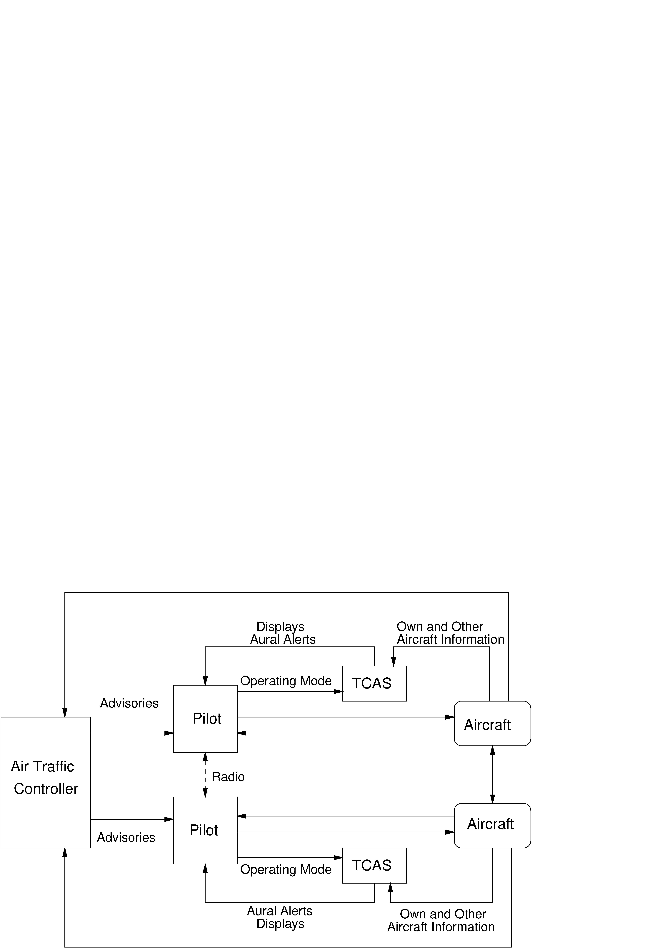

Figure 3 – General TCAS Control Structure

For this paper, we will consider only the NMAC hazard. The first step in the analysis is to define the basic control structure. The control structure for TCAS is shown in Figure 3. For this example, it is assumed that the basic system design concept is complete, i.e., each of the system components has high-level functional requirements assigned to it. In fact, a STAMP hazard analysis can be performed as the system is being defined, and this parallel refinement of the system design and hazard analysis is clearly the best approach. Tradeoff decisions and design decisions can then be evaluated for safety as they are being made. However, size limitations for this paper preclude going through a complete system design for TCAS including the design alternatives; the structure in Figure 3 (which is the current TCAS structure) is instead assumed.

After the general control structure has been defined (or a candidate structure has been identified), the next step is to determine how the controlled system (the two aircraft) can get into a hazardous state. A STAMP hazard analysis starts by identifying potential inadequate control actions that could lead to the hazardous aircraft state. In general, a controller can provide four general types of inadequate control:
- A required control action is not provided.
- An incorrect or unsafe control action is provided.
- A potentially correct or adequate control action is provided too late (at the wrong time).
- A correct control action is stopped too soon.

Control actions may be required to handle component failures, environmental disturbances, or dysfunctional interactions among the components. Incorrect or unsafe control actions may cause dysfunctional behavior or interactions among components.

Control actions in TCAS are called resolution advisories or RAs. An RA is an aircraft escape maneuver created by TCAS for the pilots to follow. Example resolution advisories are DESCEND, INCREASE RATE OF CLIMB TO 2500 FPM, and DON'T DESCEND. For the TCAS component of the control structure in Figure 3 and the NMAC hazard, the four types of control flaws translate into:
- The aircraft are on a near collision course and TCAS does not provide an RA.
- The aircraft are in close proximity and TCAS provides an RA that degrades vertical separation.
- The aircraft are on a near collision course and TCAS provides a maneuver too late to avoid an NMAC.
- TCAS removes an RA too soon.

For the pilot, the inadequate control actions are:
- The pilot does not follow the resolution advisory provided by TCAS (does not respond to the RA).
- The pilot incorrectly executes the TCAS resolution advisory.
- The pilot applies the resolution advisory but too late to avoid the NMAC.
- The pilot stops the RA maneuver too soon

Similar hazardous control actions can be identified for each of the other system components. While Figure 3 includes only the technical and operational control loops, there are also managerial and regulatory controls that need to be considered, including in this case ATC management, the FAA, airline pilot management, etc. This paper considers only the immediate technical TCAS system and its operators, but a similar analysis is possible and important at the management and social levels as well.

The next step is to determine how these potentially hazardous control actions can occur and either to eliminate them through system or component design or to control or mitigate them in the design or operations. This step is accomplished using a formal model of the system and the set of control loop flaws shown in Figure 4. Note that as the system design progresses, more ways to get into the hazardous state will be identified. The analysis can start early (and should in order to have a chance to eliminate hazards), but it will need to be continued and augmented throughout the system design and development process.

The modeling language we use is SpecTRM-RL, which produces executable and analyzable models. A continuous simulation environment can be maintained as the system design progresses and the effects of design decisions can be evaluated (both through simulation and analysis) as they are proposed. SpecTRM-RL models look very much like standard control loop diagrams, with the addition of a model of the controlled process in each control component. Previously we have only used SpecTRM-RL to model software components, but it can also be used for humans including both the immediate system operators and the managers and regulators involved in the larger system structure.

The basic control structure in Figure 3 is first augmented with the process (plant) model required for each of the control components in the control structure. Additions may be needed as hazards are identified and analyzed and mitigations proposed. An important aspect of a STAMP hazard analysis is that the use of formal models allows the mitigation features and the impact of various types of faults in other components of the control structure to be evaluated during the hazard analysis process.

The information TCAS needs to know to create RAs can be modeled in SpecTRM-RL. For TCAS itself, this process model contains information about the controlled aircraft (altitude, speed, bearing, etc.), information about other aircraft that are potential threats (ranges, bearings, altitudes, etc.), and models of the current state of the pilot displays and controls. Some of the information contained in the process model will be obtained through direct inputs from sensors while other information will be derived from processing those inputs (e.g., the threat status of the other aircraft). The SpecTRM-RL TCAS model also includes a description of the logic for updating and using the process variable values. The logic is described using AND/OR tables.

The process (internal models) of each other part of the control structure must also be modeled. For example, the pilots must have a model of their own aircraft state, information about other aircraft that are threats or potential threats, and a model of the operational state of their TCAS systems. The ATC controller must have a model of the critical airspace features (e.g., the location of aircraft and predicted trajectories and conflicts). Inconsistencies between these various models contributed to the recent collision over Lake Constance in Europe.

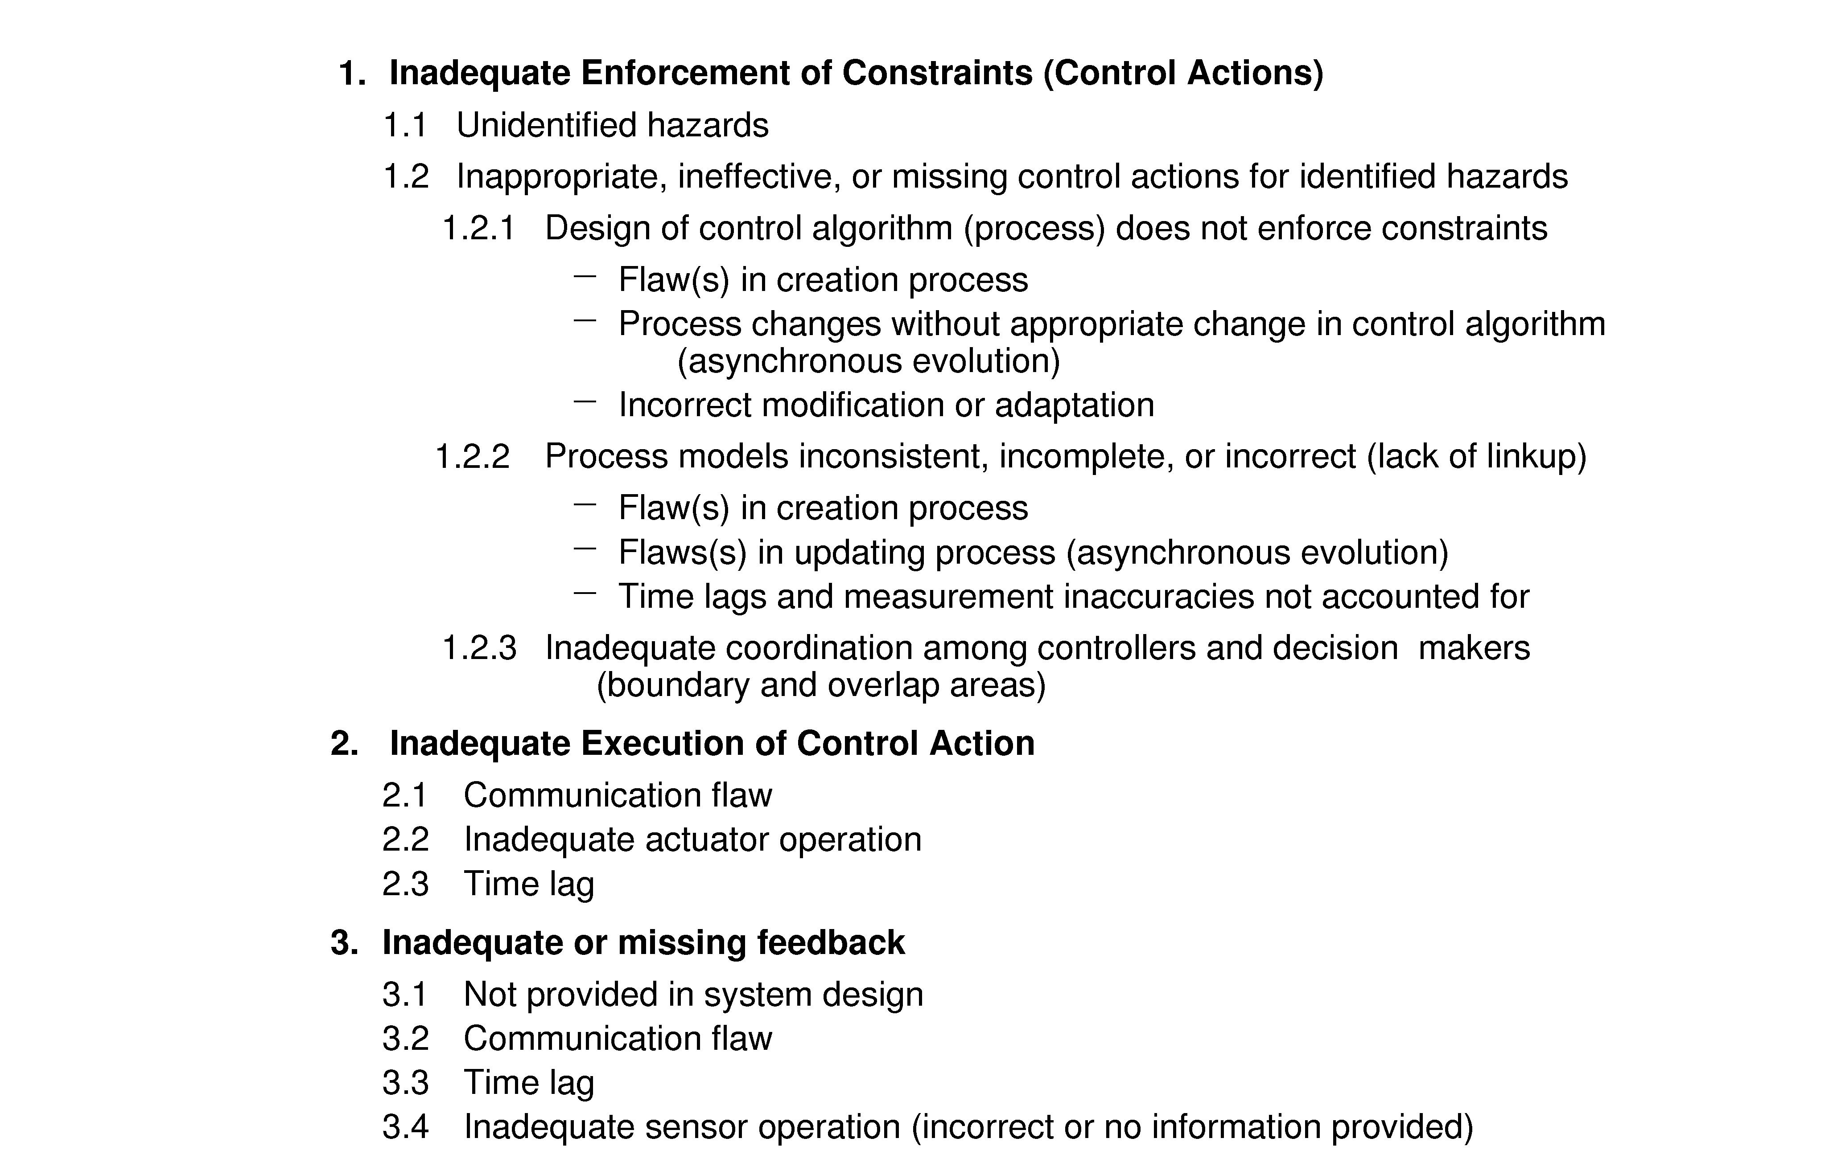

Figure 4 – Control Loop Flaws

Next, for each of the inadequate control actions identified, the parts of the control loop within which the controller is embedded are examined to determine if they could cause that control action (or lack of a necessary control action). Consider the possibility of TCAS not providing an RA when one is required to avoid an NMAC. One way this omission might occur is if the model of the other aircraft is not consistent with the other aircraft’s actual state, i.e., the model does not classify the other aircraft as a potential threat. How could this occur? Process models, as stated above, have three parts: initial values for the process variables, a current state, and an algorithm for updating the current state over time based on inputs from sensors and other sources. Each of these must be examined for their potential to cause the hazardous control action.

First, the algorithm used to classify threats is examined for correctness and to determine what environmental information it requires. Then each part of the control loop is examined to determine how that information might not be provided, might be provided at the wrong time, or might contain a hazardous value. For example, the sensors that provide critical information about the other aircraft’s state may not work correctly. Alternatively, they may be working, but the information received may be incorrect, either being garbled enroute or being incorrectly sent by the other aircraft. In addition, the transmission may be lost and no information may be received. Each of these cases will need to be accounted for in the design in some way.

Initial startup and restart after a temporary shutdown are times when accidents often occur. Particular attention needs to be paid to the consistency of the controller’s inferred process model and the state of the controlled process at these times. For example, the TCAS logic assumes the system would be powered up while the aircraft is on the ground. This assumption is important because no RAs are provided when the aircraft is below 500 feet above ground level in order to avoid interfering with landing operations. If TCAS is powered up in the air (perhaps when the pilot discovers a possible problem and reboots the system) and the initial default value for altitude is zero, no RAs will be provided until TCAS gets a reading from its own altimeter even though the pilot may think that TCAS is fully operational. Because this type of initialization problem upon startup is so commonplace, SpecTRM-RL includes (and encourages the use of) an “unknown” value for every state variable in the process models. SpecTRM-RL provides other types of assistance in detecting and avoiding common mistakes made by designers that can lead to hazardous controller behavior (ref. 4).

Another reason for not issuing an RA when required (and for the other types of inadequate control actions) might be related to inaccuracies in the measurements used to derive the current values of state variables in the process model or related to time lags in the control loop. For example, in TCAS II, relative range positions of other aircraft are computed based on round-trip message propagation time. Measurement inaccuracies and time lags can affect that computation and must be considered in the hazard analysis.

Information about the process state has to be inferred from measurements. The theoretical control function (control law) uses the true values of the controlled variables or component states (e.g., true aircraft positions). The controller, however, must use measured values to infer the true conditions in the process and, if necessary, to derive corrective actions to maintain the required process state. In TCAS, sensors include devices such as altimeters that provide measured altitude, but not necessarily true altitude. The mapping between measured or assumed values may be flawed or time lags that are not accounted for may cause the process model to be incorrect.

Control actions will, in general, lag in their effects on the process because of delays in signal propagation around the control loop: an actuator may not respond immediately to an external command signal (called dead time), the process may have delays in responding to manipulated variables (time constants), and the sensors may obtain values only at certain sampling intervals (feedback delays).

Time lags restrict the speed and extent with which the effects of disturbances, both within the process itself and externally derived, can be reduced. Time lags may also occur between issuing a command and the actual process state change, such as pilot response delays and aircraft performance limitations (which will affect the aircraft trajectory). Finally, time lags may impose extra requirements on the controller, for example, the need to infer delays that are not directly observable. Depending on where in the feedback loop the delay occurs, different process models and controls may be required to cope with the delays: dead time and time constants require a model that makes it possible to predict when an action is needed before the need arises while feedback delays require a model that allows prediction of when a given action has taken effect and when resources will be available again.

So far, only a missing RA has been considered. The complete hazard analysis must consider each hazardous control action and determine if and how each of the types of control loop flaws shown in Figure 4 can lead to the inadequate control. The information that results can be used to design appropriate mitigation measures.

The STAMP hazard analysis is not over yet, however. Once an effective and safe control structure has been designed, the analysis must also consider how the designed controls could degrade in effectiveness over time. The results should be used to design auditing and performance measures (metrics) for operational procedures and management feedback channels to detect such degradation.

The safety control structure often changes over time, which accounts for the observation that accidents in complex systems frequently involve a migration of the system toward a state where a small deviation (in the physical system or in human operator behavior) can lead to a catastrophe. The foundation for an accident is often laid years before. One event may trigger the loss, but if that event had not happened, another one would have. Union Carbide and the Indian government blamed the Bhopal MIC (methyl isocyanate) release (among the worst industrial accidents in history) on human error⎯the improper cleaning of a pipe at the chemical plant. However, this event was only a proximate factor in the loss. Degradation in the safety margin at the Union Carbide Bhopal plant had occurred over many years, without any particular single decision to do so but simply as a series of decisions that moved the plant slowly toward a situation where any slight error would lead to a major accident.

Such degradation of the safety-control structure over time may be related to asynchronous evolution (ref. 1), where one part of a system changes without the related necessary changes in other parts. Changes to subsystems may be carefully designed, but consideration of their effects on other parts of the system, including the control aspects, may be neglected or inadequate. Asynchronous evolution may also occur when one part of a properly designed system deteriorates. In both these cases, the erroneous expectations of users or system components about the behavior of the changed or degraded subsystem may lead to accidents. The Ariane 5 trajectory changed from that of the Ariane 4, but the inertial reference system software did not. One factor in the loss of contact with the SOHO (SOlar Heliospheric Observatory) spacecraft in 1998 was the failure to communicate to operators that a functional change had been made in a procedure to perform gyro spin-down.

A complete hazard analysis must identify the possible changes to the safety control structure over time that could lead to a high-risk state. STAMP analyses use systems dynamics models (ref. 1) to model dynamic behavior. The dynamic models can be used to identify likely changes over time that are detrimental to safety. This information can then be used to generate operational auditing and performance measurements to detect when such degradation is occurring and to design controls on potential maintenance, system changes, and upgrade activities.

Conclusions

A new approach to hazard analysis for complex, software-intensive systems has been outlined. The approach, based on a new model of accident causation called STAMP, has some similarities with HAZOP in that both operate on a concrete model. STAMP, however, uses a logical model of the control structure rather than just a physical model of the plant, and it bases the analysis on inadequate (hazardous) control actions rather than deviations in process variables (although such deviations are included in a STAMP analysis).

The model of the control structure used in a STAMP hazard analysis can be implemented using SpecTRM-RL and therefore automated tools can assist the analyst through simulation (execution of the models) and various types of formal analysis.

A preliminary comparison of the results of a STAMP analysis of TCAS II with the fault tree used in the original certification of TCAS shows the results of the STAMP analysis to be more comprehensive. A more detailed comparison is underway as well as generation of examples of STAMP-based hazard analyses applied to other types of systems.

References

1. Nancy Leveson. A Systems Model of Accidents, International Conference of the System Safety Society, Denver, 2002.

2. Nancy Leveson. The Analysis of a Friendly Fire Accident using a System Model of Accidents, International Conference of the System Safety Society, Denver 2002.

3. Nancy Leveson, Mirna Daouk, Nicolas Dulac, and Karen Marais. Applying STAMP in Accident Analysis, Workshop on the Investigation and Reporting of Accidents, September 2003.

4. Nancy G. Leveson. Safeware: System Safety and Computers, Addison Wesley, 1995.

Biography

Prof. Nancy G. Leveson, Aeronautics and Astronautics Dept., MIT, Room 33-313, 77 Massachusetts Ave., Cambridge 02139, telephone – (617) 258-0505. facsimile – (617) 253-7397, email – Leveson@mit.edu.

