Safety in Integrated Systems Health Engineering and Management

Nancy G. Leveson
Aeronautics and Astronautics
Engineering Systems
MIT

Abstract: This paper describes the state of the art in system safety engineering and management along with new models of accident causation, based on systems theory, that may allow us to greatly expand the power of the techniques and tools we use. The new models consider hardware, software, humans, management decision-making, and organizational design as an integrated whole. New hazard analysis techniques based on these expanded models of causation provide a means for obtaining the information necessary to design safety into the system and to determine which are the most critical parameters to monitor during operations and how to respond to them. The paper first describes and contrasts the current system safety and reliability engineering approaches to safety and the traditional methods used in both these fields. It then outlines the new systems-theoretic approach being developed in Europe and the U.S. and the application of the new approach to aerospace systems, including a recent risk analysis and health assessment of the NASA manned space program management structure and safety culture that used the new approach.

Reliability Engineering vs. System Safety

Although safety has been a concern of engineering for centuries and references to designing for safety appear in the 19th century (Cooper, 1891), modern approaches to engineering safety appeared as a result of changes that occurred in the mid-1900s.
In the years following World War II, the growth in military electronics gave rise to reliability engineering. Reliability was also important to NASA and our space efforts, as evidenced by the high failure rate of space missions in the late 1950s and early 1960s and was adopted as a basic approach to achieving mission success. Reliability engineering is concerned primarily with failures and failure rate reduction. The reliability engineering approach to safety thus concentrates on failure as the cause of accidents. A variety of techniques are used to minimize component failures and thereby the failures of complex systems caused by component failure. These reliability engineering techniques include parallel redundancy, standby sparing, built-in safety factors and margins, derating, screening, and timed replacements.
System Safety arose around the same time, primarily in the defense industry. Although many of the basic concepts of system safety, such as anticipating hazards and accidents and building in safety, predate the post-World War II period, much of the early development of system safety as a separate discipline began with flight engineers immediately after the War and was developed into a mature discipline in the early ballistic missile programs of the 1950s and 1960s. The space program was the second major application area to apply system safety approaches in a disciplined manner. After the Apollo 204 fire in 1967, NASA hired Jerome Lederer, the head of the Flight Safety Foundation, to head manned space-flight safety and, later, all safety activities. Through his leadership, an extensive program of system safety was established for space projects, much of it patterned after the Air Force and DoD programs.
While traditional reliability engineering techniques are often effective in increasing reliability, they do not necessarily increase safety. In fact, their use under some conditions may actually reduce safety. For example, increasing the burst-pressure to working-pressure ratio of a tank often introduces new dangers of an explosion or chemical reaction in the event of a rupture.
System safety, in contrast to the reliability engineering focus on preventing failure, is primarily concerned with the management of hazards: their identification, evaluation, elimination, and control through analysis, design and management procedures. In the case of the tank rupture, system safety would look at the interactions among the system components rather than just at failures or engineering strengths.
Reliability engineers often assume that reliability and safety are synonymous, but this assumption is true only in special cases. In general, safety has a broader scope than failures, and failures may not compromise safety. There is obviously an overlap between reliability and safety, but many accidents occur without any component failure, e.g., the Mars Polar Lander loss, where the individual components were operating exactly as specified or intended, that is, without failure. The opposite is also true—components may fail without a resulting accident. In addition, accidents may be caused by equipment operation outside the parameters and time limits upon which the reliability analyses are based. Therefore, a system may have high reliability and still have accidents. For example, the Therac-25 (a medical device that massively overdosed several patients) worked safely tens of thousands of time before the peculiar conditions arose that triggered the software flaw that killed a patient.
Chernobyl-style nuclear power plants had a calculated mean time between failure of ten thousand years.
System safety deals with systems as a whole rather than with subsystems or components. In system safety, safety is treated as an emergent property that arises at the system level when components are operating together. The events leading to an accident may be a complex combination of equipment failure, faulty maintenance, instrumentation and control problems, human actions, and design errors. Reliability analysis considers only the possibility of accidents related to failures; it does not investigate the potential damage that could result from successful operation of the individual components.
Another unique feature of system safety engineering is its inclusion of non-technical aspects of systems. Jerome Lederer wrote in 1968:
“System safety covers the entire spectrum of risk management. It goes beyond the hardware and associated procedures to system safety engineering. It involves: attitudes and motivation of designers and production people, employee/management rapport, the relation of industrial associations among themselves and with government, human factors in supervision and quality control, documentation on the interfaces of industrial and public safety with design and operations, the interest and attitudes of top management, the effects of the legal system on accident investigations and exchange of information, the certification of critical workers, political considerations, resources, public sentiment and many other non-technical but vital influences on the attainment of an acceptable level of risk control. These non-technical aspects of system safety cannot be ignored (quoted in Lederer, 1986).

Traditional Accident Models and Approaches to Safety Engineering

Models provide a means for understanding phenomena and recording that understanding so we can communicate with others. Accident models underlie all attempts to engineer for safety; they are used to explain how accidents occur. All accident models assume there exist common patterns in accidents—that they are not just random events. Imposing a pattern on accidents influences the factors that are considered in investigating and analyzing accidents, preventing accidents through hazard analysis and design techniques, assessing risk, and performance auditing. While you may not be aware that you are using an accident model, it underlies all causal identification, countermeasures taken, and risk evaluation.
The most common model used today explains accidents in terms of multiple failure events, sequenced as a forward chain over time. The relationships between the events are simple and direct, e.g., if A hadn’t occurred, B would not have happened. Figure 1 shows an example of an accident chain model for the rupture of a tank. The events in the chain almost always involve component failure, human error, or energy-related events such as an explosion.
Chain-of-events models form the basis for most system safety and reliability engineering analyses used today, such as fault tree analysis, failure modes and effects analysis, event trees, and probabilistic risk assessment. Note that hazard analysis is simply the investigation of an accident before it occurs: Techniques such as fault tree analysis or failure modes and effects analysis attempt to delineate all the relevant chains of events that can lead to the loss event being investigated.
The event chain models that result from this analysis form the basis for most reliability and safety engineering design techniques, such as redundancy, overdesign, safety margins, interlocks, etc. The designer attempts to interrupt the chain of events by preventing the occurrence of events in the chain. Figure 1 is annotated with some potential design techniques that might be used to interrupt the flow of events to the loss state. Not shown, but very common, is to introduce “and” relationships in the chain, i.e., to design such that two or more failures must happen for the chain to continue toward the loss state, thus reducing the probability of the loss occurring.

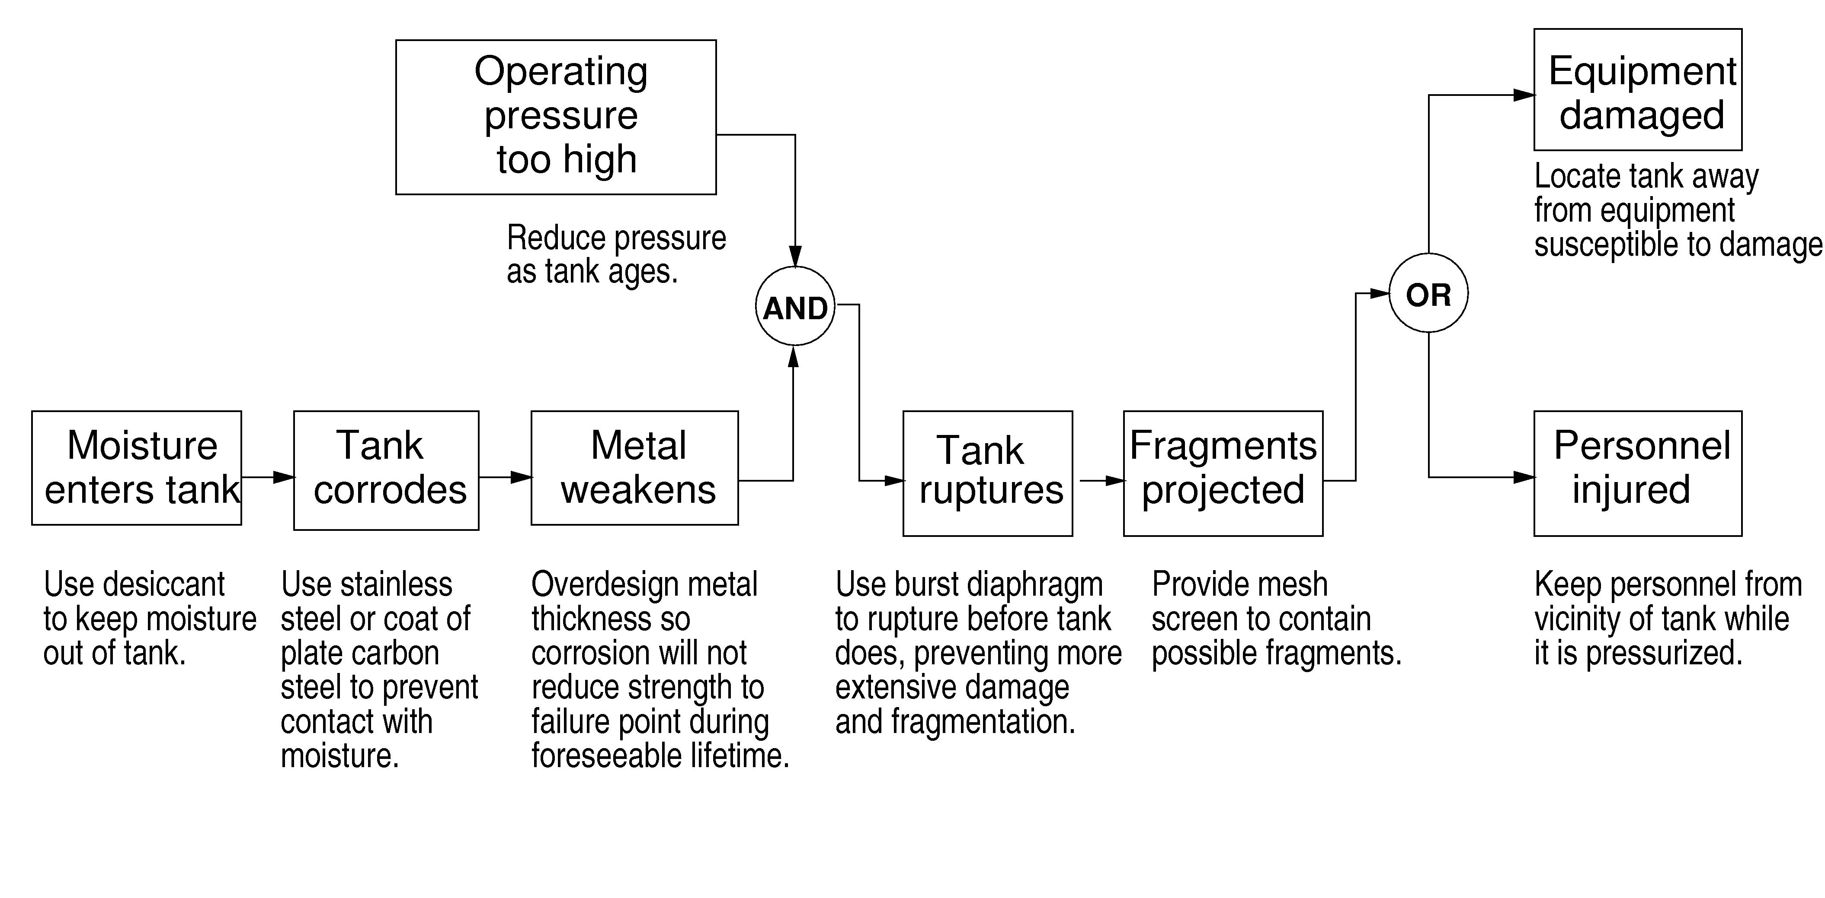
Figure 1: Chain-of-Events Accident Model Example

Reliability engineering relies on redundancy, increasing component integrity (e.g., incorporating safety margins for physical components and attempting to achieve error-free behavior of the logical and human components) and using “safety” functions during operations to recover from failures (e.g., shutdown and other types of protection systems). System safety uses many of the same techniques, but focuses them on eliminating or preventing hazards. System safety engineers also tend to use a wider variety of design approaches, including various types of interlocks to prevent the system from entering a hazardous state or leaving a safe state.
In summary, reliability engineering focuses on failures while system safety focuses on hazards. These are not equivalent. C.O.Miller, of the founders of system safety in the 1950s, cautioned that “distinguishing hazards from failures is implicit in understanding the difference between safety and reliability” (Miller, 1985).
While both of these approaches work well with respect to their different goals for the relatively simple systems for which they were designed in the 1950 and 1960s, they are not as effective for the complex systems and new technology common today. The basic hazard analysis techniques have not changed significantly since Fault Tree Analysis was introduced in 1962. The introduction of digital systems and software control, in particular, has had a profound effect in terms of technology that does not satisfy the underlying assumptions of the traditional hazard and reliability analysis and safety engineering techniques. It also allows levels of complexity in our system designs that overwhelms the traditional approaches (Leveson 1995, Leveson 2005). A related new development is the introduction of distributed human-automation control and the changing role of human operators from controller to high-level supervisor and decision-maker. The simple slips and operational mistakes of the past are being eliminated by substituting automation, resulting in a change in the role humans play in accidents and the substitution of cognitively complex decision-making errors for the simple slips of the past. In the most technically advanced aircraft, the types of errors pilots make have changed but not been eliminated (Billings, 1996).
Another important limitation of the chain-of-events model is that it ignores the social and organizational factors in accidents. Both the Challenger and Columbia accident reports stressed the importance of these factors in accident causation. Poor engineering and management decision-making and processes can outweigh and undo good analysis and design of the physical system.
Finally, any accident model that includes the social system and human error must account for adaptation. Systems and organizations continually change as adaptations are made in response to local pressures and short-term productivity and cost goals. People adapt to their environment or they change their environment to better suit their purposes. A corollary of this propensity for systems and people to adapt over time is that safety defenses are likely to degenerate systematically through time, particularly when pressure toward cost-effectiveness and increased productivity is the dominant element in decision-making (Rasmussen 1997). Major accidents are often caused not merely by a coincidence of independent failures but instead reflect a systematic migration of the organizational behavior to the boundaries of safe behavior under pressure toward cost-effectiveness in an aggressive, competitive environment.
For an accident model to handle system adaptation over time, it must consider the processes involved in accidents and not simply events and conditions: Processes control a sequence of events and describe system and human behavior over time rather than considering events and human actions individually. Rasmussen argues that accident causation must be viewed as a complex process involving the entire socio-technical system including legislators, government agencies, industry associations and insurance companies, company management, technical and engineering personnel, operations, etc.
All of these factors are giving rise to a new type of accident, labeled by Perrow as a “system accident” (Perrow, 1984). In these accidents, losses occur due to dysfunctional interactions among components rather than component failures. Perrow hypothesized that they were related to the increased interactive complexity and tight coupling in modern high technology systems. Perrow was pessimistic about whether such accidents can be prevented, but his pessimism was based on the use of traditional reliability engineering techniques, particularly redundancy. System Safety does not rely on redundancy and system safety engineers have been working on developing more effective new techniques based on system theory to prevent system accidents.

New System-Theoretic Approaches to Safety Engineering

In parallel to the rise of system safety in the United States, some Europeans began to reject the basic chain of events models and suggested that systems theory be used as the basis for a new, more powerful model of accidents. The leader of this group was Jens Rasmussen, a researcher in the nuclear power field at Riso Labs in Denmark.
Rasmussen and Svedung have described a hierarchical model of the socio-technical system involved in risk management (see Figure 2) (Rasmussen and Svedung 2000). At the social and organizational levels of their model, Rasmussen and Svedung use a control-based model of accidents and at all levels they focus on information flow. At each level, however, and between levels, they model the events and their initiation and flow of effects using an event-chain modeling language similar to cause-consequence diagrams (which combine fault trees and event trees). In addition, they focus on the downstream part of the chain following the occurrence of the hazard. This downstream emphasis is common in the process industry, where Rasmussen has done most of his work. Finally, their model focuses on operations—engineering design activities are treated as input to the model but not as a central part of the model itself.
Leveson (2005) has taken the systems approach one step further by developing a pure systems-theoretic model of accident causation called STAMP (Systems-Theoretic Accident Modeling and Processes). In many ways, STAMP is a return to the original roots of early System Safety, but it extends the scope of what can be handled to include the new factors common to engineered systems today.

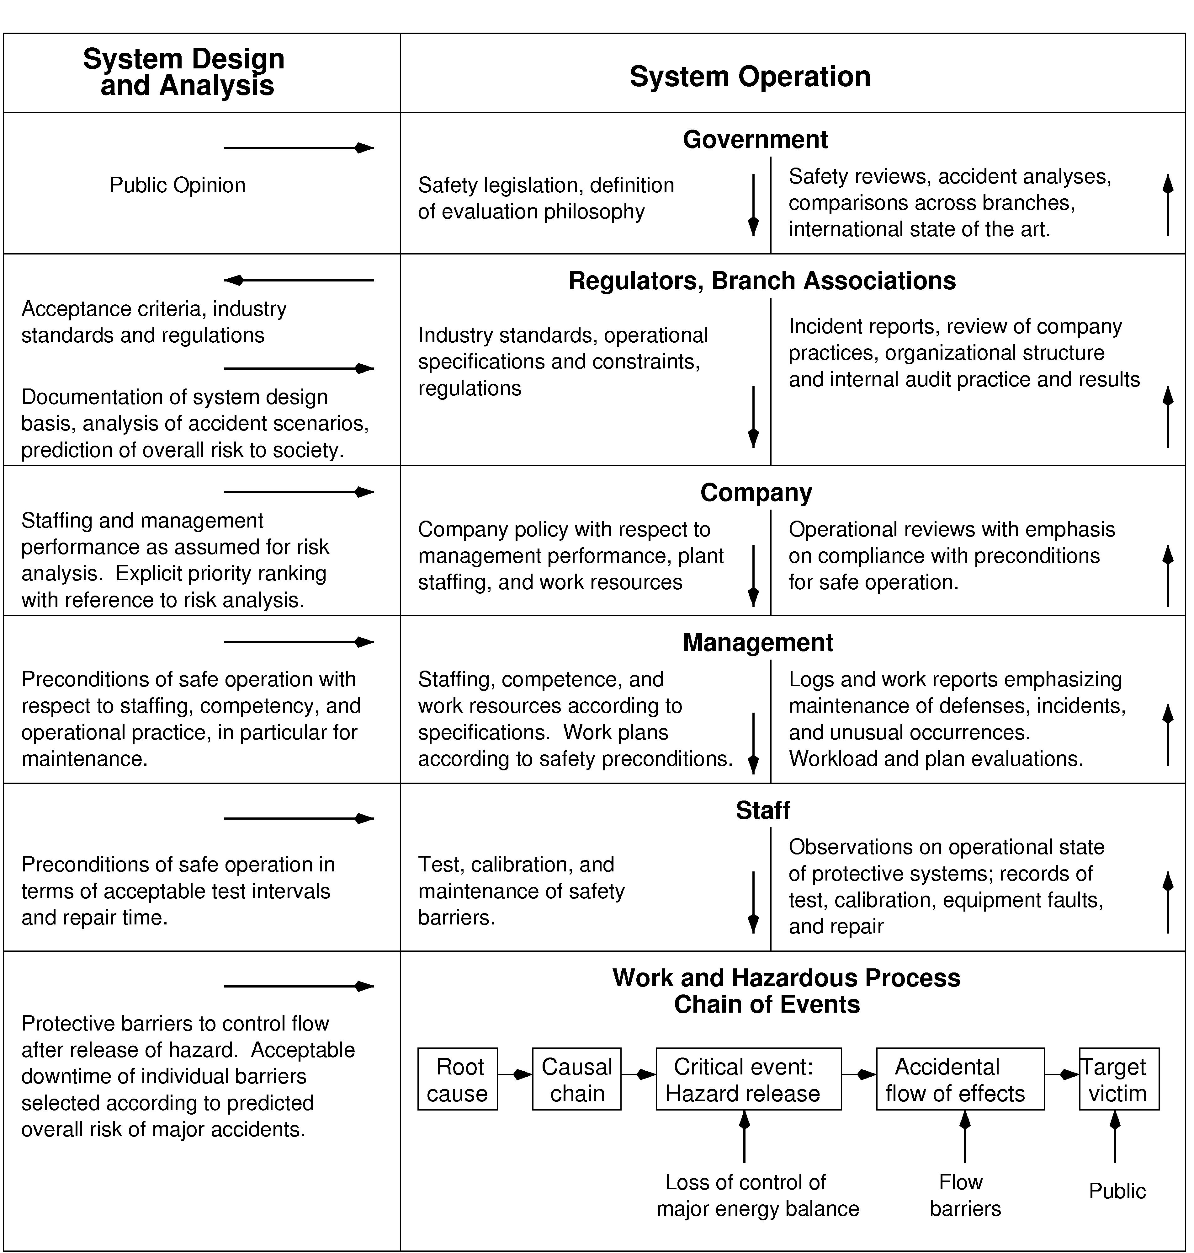

Figure 2. Rasmussen Socio-Technical Model for Risk Management

STAMP

In STAMP, accidents are not viewed as resulting from component failures but rather as a result of flawed processes involving interactions among physical system components, people, societal and organizational structures, and engineering activities. Safety is treated as a control problem: accidents occur when component failures, external disturbances, and/or dysfunctional interactions among system components are not adequately handled. In the Space Shuttle Challenger loss, for example, the O-rings did not adequately control propellant gas release by sealing a tiny gap in the field joint. In the Mars Polar Lander loss, the software did not adequately control the descent speed of the spacecraft—it misinterpreted noise from a sensor as an indication the spacecraft had reached the surface of the planet.
Accidents such as these, involving engineering design errors and misunderstanding of the functional requirements (in the case of the Mars Polar Lander), may in turn stem from inadequate control over the development process, i.e., risk is not adequately managed in the design, implementation, and manufacturing processes. Control is also imposed by the management functions in an organization—the Challenger accident involved inadequate controls in the launch-decision process, for example—and by the social and political system within which the organization exists. The role of all of these factors must be considered in hazard and risk analysis.
Note that the use of the term “control” does not imply a strict military-style command and control structure. Behavior is controlled or influenced not only by direct management intervention, but also indirectly by policies, procedures, shared values, and other aspects of the organizational culture. All behavior is influenced and at least partially “controlled” by the social and organizational context in which the behavior occurs. Engineering this context can be an effective way of creating and changing a safety culture.
Systems are viewed in STAMP as interrelated components that are kept in a state of dynamic equilibrium by feedback loops of information and control. A system is not treated as a static design, but as a dynamic process that is continually adapting to achieve its ends and to react to changes in itself and its environment. The original design must not only enforce appropriate constraints on behavior to ensure safe operation, but it must continue to operate safely as changes and adaptations occur over time. Accidents, then, are considered to result from dysfunctional interactions among the system components (including both the physical system components and the organizational and human components) that violate the system safety constraints. The process leading up to an accident can be described in terms of an adaptive feedback function that fails to maintain safety as performance changes over time to meet a complex set of goals and values. The accident or loss itself results not simply from component failure (which is treated as a symptom of the problems) but from inadequate control of safety-related constraints on the development, design, construction, and operation of the socio-technical system.
While events reflect the effects of dysfunctional interactions and inadequate enforcement of safety constraints, the inadequate control itself is only indirectly reflected by the events—the events are the result of the inadequate control. The system control structure itself, therefore, must be examined to determine how unsafe events might occur and if the controls are adequate to maintain the required constraints on safe behavior.
STAMP has three fundamental concepts: constraints, hierarchical levels of control, and process models. These concepts, in turn, give rise to a classification of control flaws that can lead to accidents.
The most basic component of STAMP is not an event, but a constraint. In systems theory and control theory, systems are viewed as hierarchical structures where each level imposes constraints on the activity of the level below it—that is, constraints or lack of constraints at a higher level allow or control lower-level behavior.
Safety-related constraints specify those relationships among system variables that constitute the non-hazardous or safe system states—for example, the power must never be on when the access to the high-voltage power source is open, the descent engines on the lander must remain on until the spacecraft reaches the planet surface, and two aircraft must never violate minimum separation requirements.
Instead of viewing accidents as the result of an initiating (root cause) event in a chain of events leading to a loss, accidents are viewed as resulting from interactions among components that violate the system safety constraints. The control processes that enforce these constraints must limit system behavior to the safe changes and adaptations implied by the constraints. Preventing accidents requires designing a control structure, encompassing the entire socio-technical system, that will enforce the necessary constraints on development and operations. Figure 3 shows a generic hierarchical safety control structure.
Accidents result from inadequate enforcement of constraints on behavior (e.g., the physical system, engineering design, management, and regulatory behavior) at each level of the socio-technical system. Inadequate control may result from missing safety constraints, inadequately communicated constraints, or from constraints that are not enforced correctly at a lower level. Feedback during operations is critical here. For example, the safety analysis process that generates constraints always involves some basic assumptions about the operating environment of the process. When the environment changes such that those assumptions are no longer true, the controls in place may become inadequate.
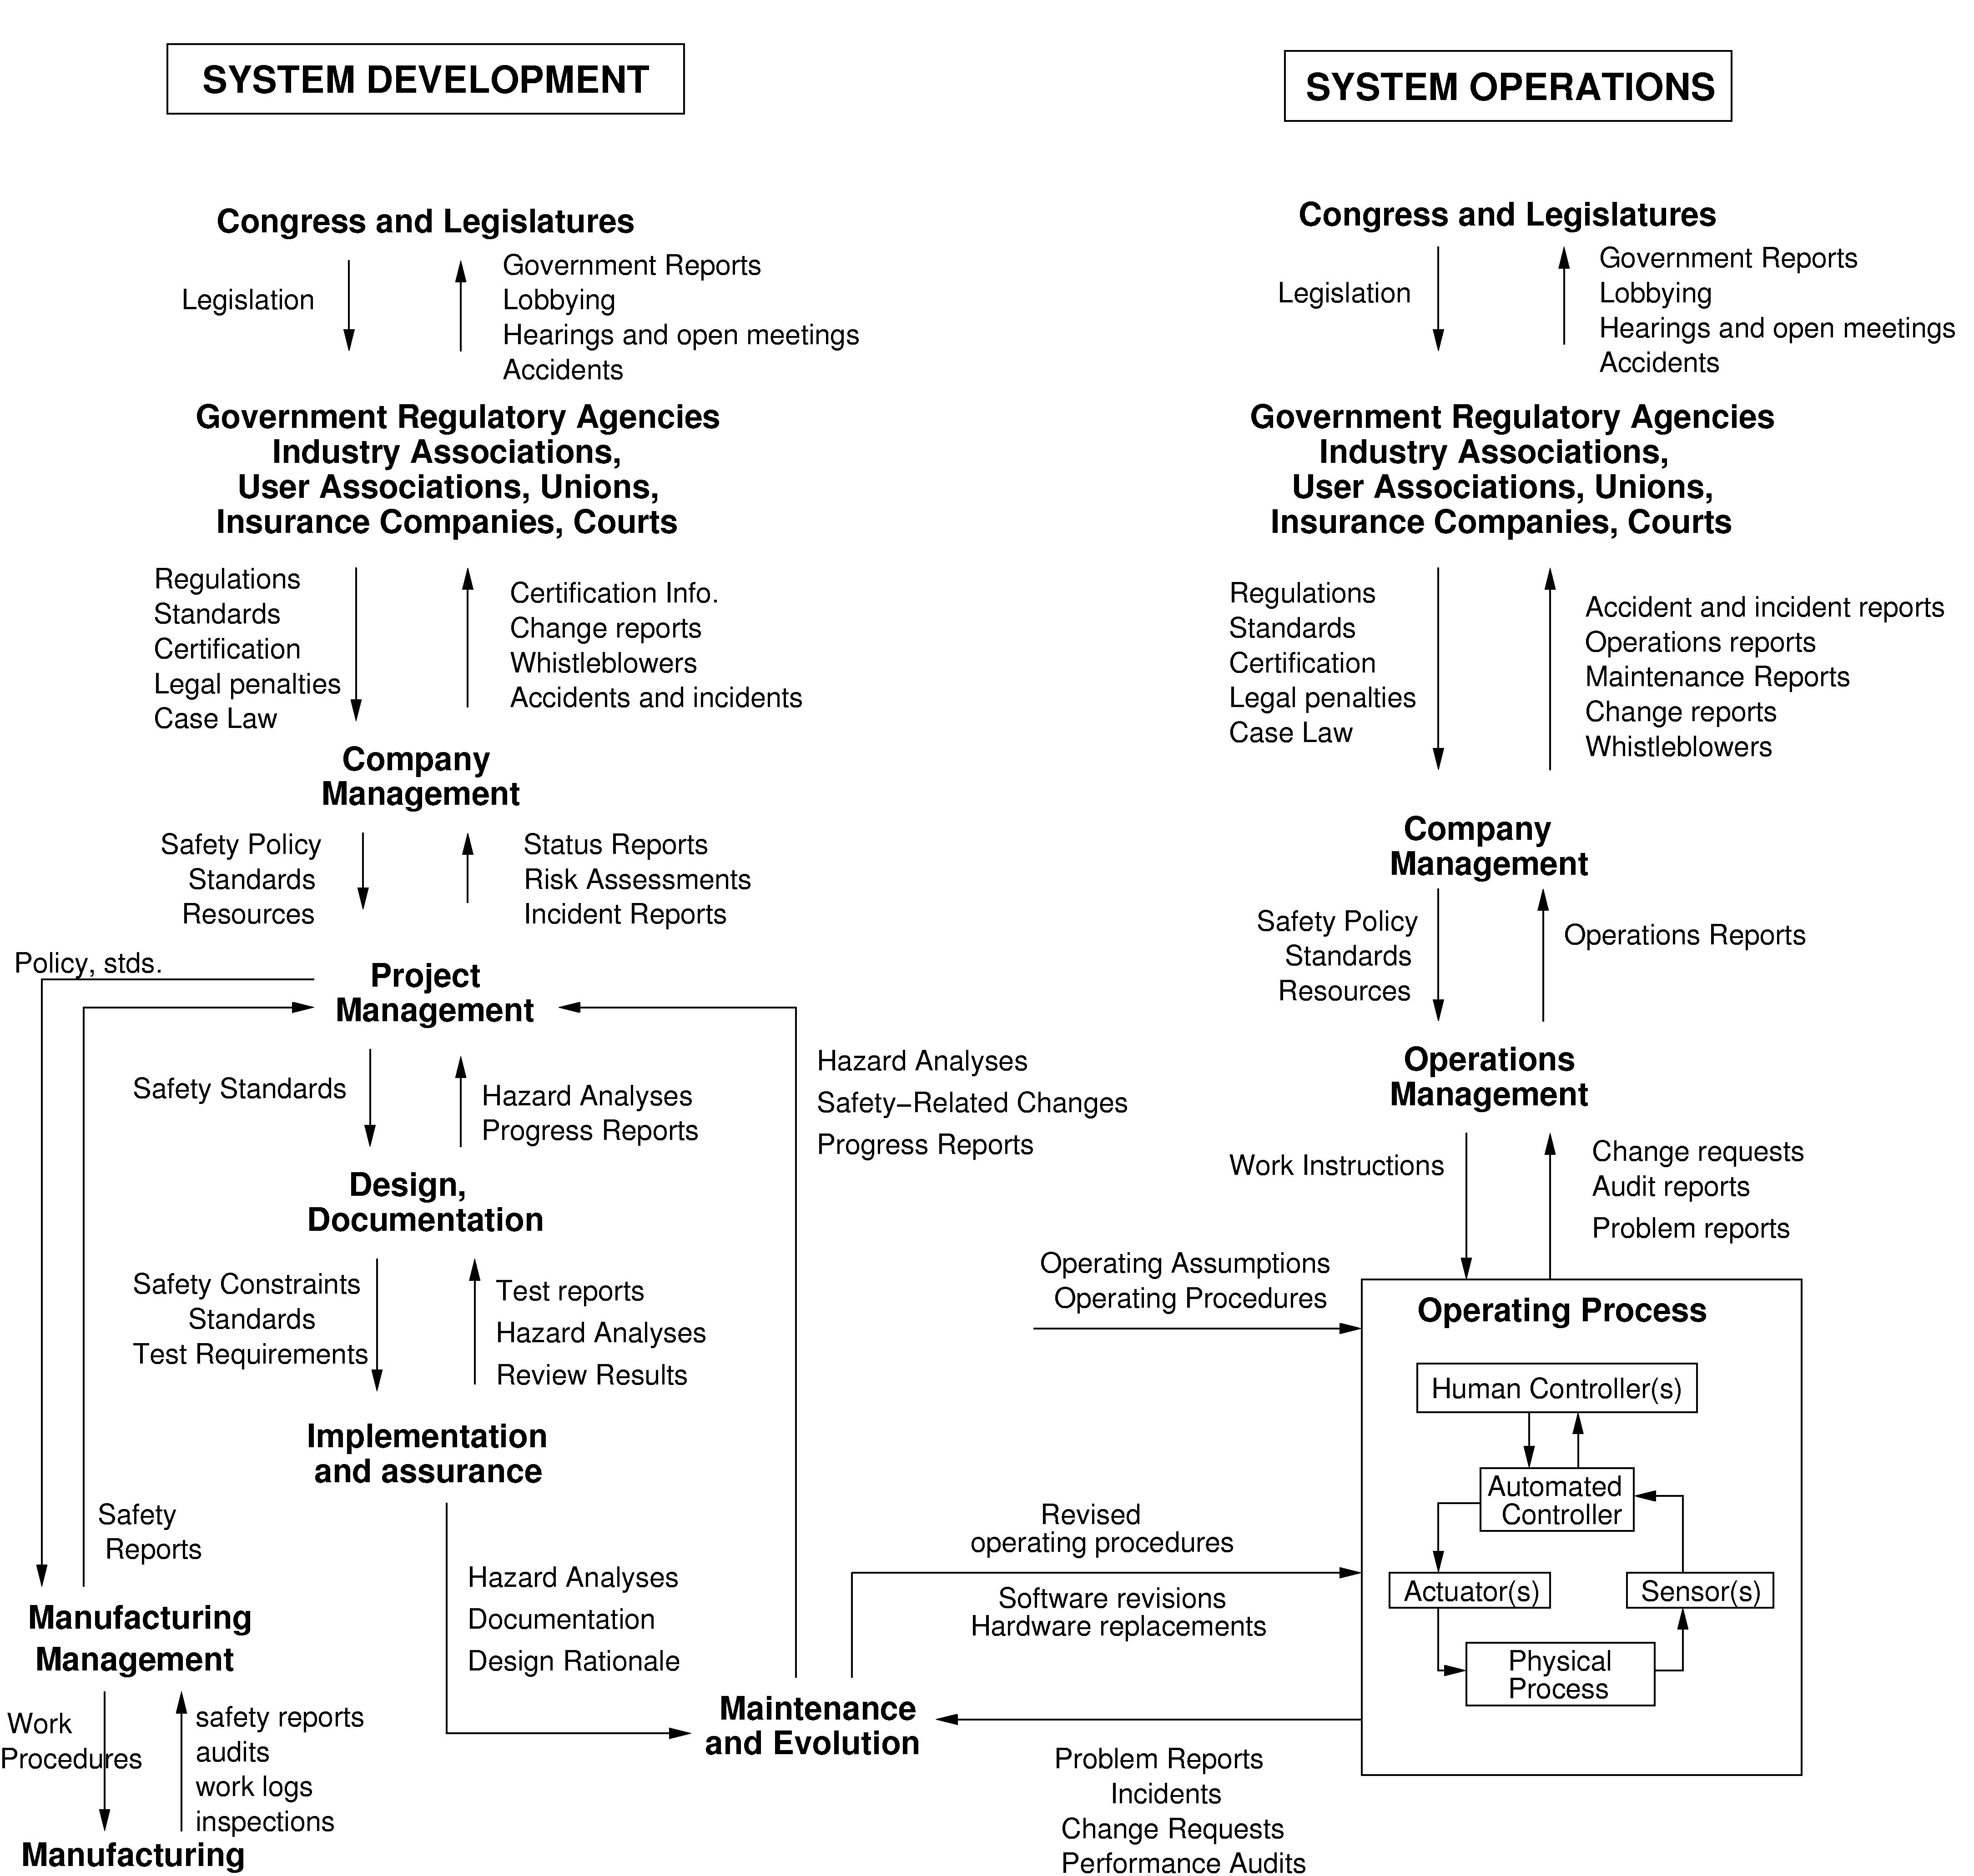

Figure 3: General Form of a Model of Socio-Technical Safety Control

The model in Figure 3 has two basic hierarchical control structures—one for system development (on the left) and one for system operation (on the right)—with interactions between them. A spacecraft manufacturer, for example, might only have system development under its immediate control, but safety involves both development and operational use of the spacecraft, and neither can be accomplished successfully in isolation: Safety must be designed into the physical system, and safety during operation depends partly on the original system design and partly on effective control over operations. Manufacturers must communicate to their customers the assumptions about the operational environment upon which their safety analysis and design was based, as well as information about safe operating procedures. The operational environment, in turn, provides feedback to the manufacturer about the performance of the system during operations.
Between the hierarchical levels of each control structure, effective communication channels are needed, both a downward reference channel providing the information necessary to impose constraints on the level below and a measuring channel to provide feedback about how effectively the constraints were enforced. For example, company management in the development process structure may provide a safety policy, standards, and resources to project management and in return receive status reports, risk assessment, and incident reports as feedback about the status of the project with respect to the safety constraints.
The safety control structure often changes over time, which accounts for the observation that accidents in complex systems frequently involve a migration of the system toward a state where a small deviation (in the physical system or in human behavior) can lead to a catastrophe. The foundation for an accident is often laid years before. One event may trigger the loss, but if that event had not happened, another one would have. As an example, Figure 4 shows the changes over time that led to a water contamination accident in Canada where 2400 people became ill and 7 died (most of them children). The reasons why this accident occurred would take too many pages to explain and only a small part of the overall STAMP model is shown. Each component of the water quality control structure played a role in the accident. The model at the top shows the control structure for water quality in Ontario Canada as designed. The figure at the bottom shows the control structure as it existed at the time of the accident. One of the important changes that contributed to the accident is the elimination of a government water-testing laboratory. The private companies that were substituted were not required to report instances of bacterial contamination to the appropriate government ministries. Essentially, the elimination of the feedback loops made it impossible for the government agencies and public utility managers to perform their oversight duties effectively. Note that the goal here is not to identify individuals to blame for the accident but to understand why they made the mistakes they made (none were evil or wanted children to die) and what changes are needed in the culture and water quality control structure to reduce risk in the future.
In this accident, and in most accidents, degradation in the safety margin occurred over time and without any particular single decision to do so but simply as a series of decisions that individually seemed safe but together resulted in moving the water quality control system structure slowly toward a situation where any slight error would lead to a major accident. Preventing accidents requires ensuring that controls do not degrade despite the inevitable changes that occur over time or that such degradation is detected and corrected before a loss occurs.
Figure 4 shows static models of the safety control structure. But models are also needed to understand why the structure changed over time in order to build in protection against unsafe changes. For this goal, we use system dynamics models. System dynamics models are formal and can be executed, like our other models. The field of system dynamics, created at MIT in the 1950s by Forrester (Forrester, 1961), is designed to help decision makers learn about the structure and dynamics of complex systems, to design high leverage policies for sustained improvement, and to catalyze successful implementation and change. System dynamics provides a framework for dealing with dynamic complexity, where cause and effect are not obviously related. Like the other models used in a STAMP analysis, it is grounded in the theory of non-linear dynamics and feedback control, but also draws on cognitive and social psychology, organization theory, economics, and other social sciences (Senge, 1990; Sterman, 2000).

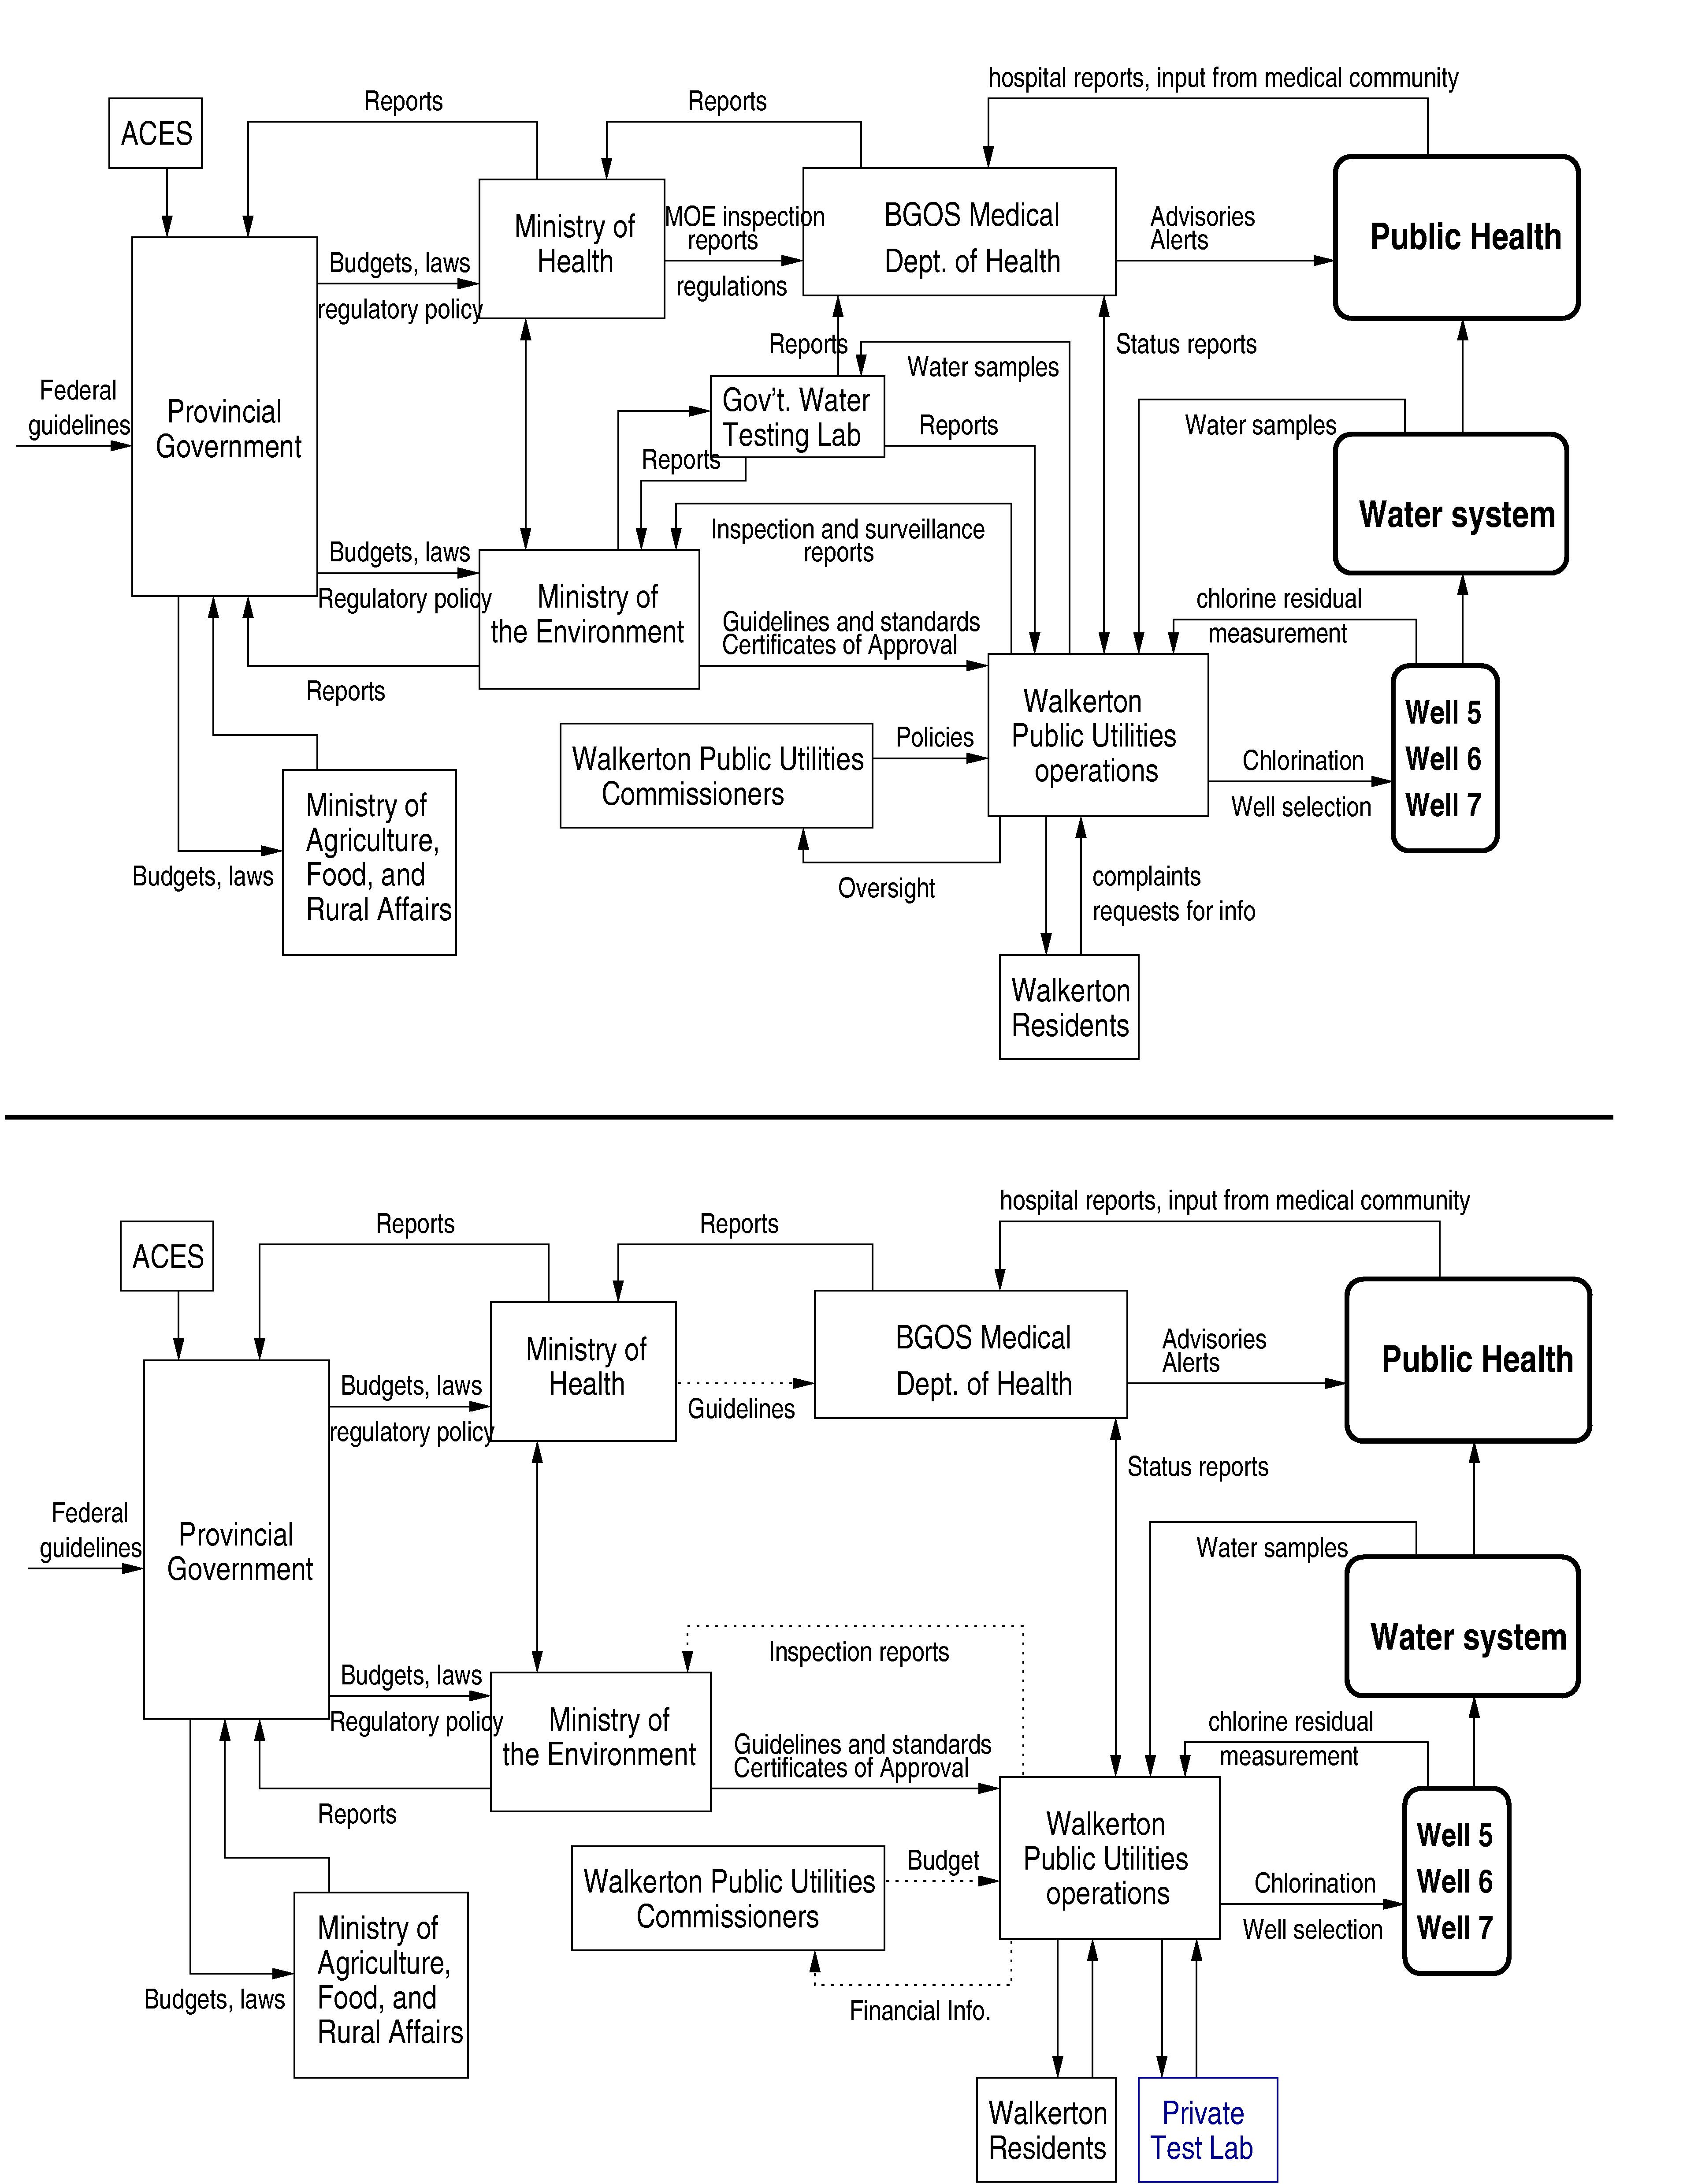

Figure 4. The Safety Control Structure in the Walkerton Water Contamination Accident. The structure is drawn in the form commonly used for control loops. Lines going into the left of a box are control lines. Lines from or to the top or bottom of a box represent information, feedback, or a physical flow. Rectangles with sharp corners are controllers while rectangles with rounded corners represent physical processes.

Figure 5 shows a simple (and incomplete) example of a system dynamics model of the factors involved in the Space Shuttle Columbia loss. There are three main variables in the model: safety, complacency, and success in meeting launch rate expectations.

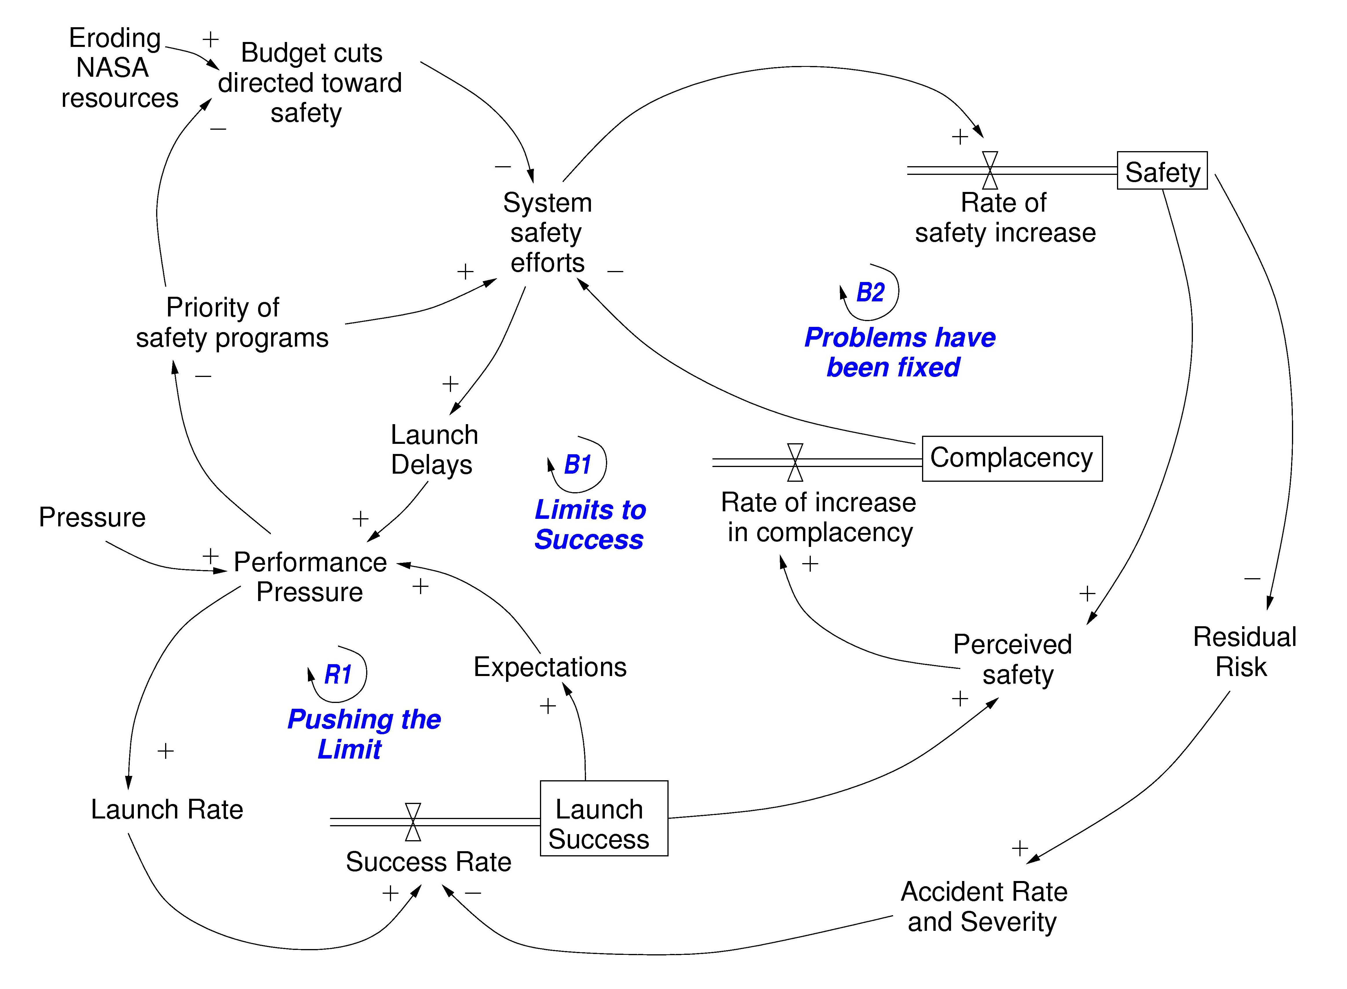
F
Figure 5. Simplified Model of the Dynamics Behind the Shuttle Columbia Loss

The control loop in the lower left corner of Figure 5, labeled R1 or Pushing the Limit, shows how as external pressures increased, performance pressure increased, which led to increased launch rates and thus success in meeting the launch rate expectations, which in turn led to increased expectations and increasing performance pressures. This, of course, is an unstable system and cannot be maintained indefinitely—note the larger control loop, B1, in which this loop is embedded, is labeled Limits to Success. The upper left loop represents part of the safety program loop. The external influences of budget cuts and increasing performance pressures that reduced the priority of safety procedures led to a decrease in system safety efforts. The combination of this decrease along with loop B2 in which fixing problems increased complacency, which also contributed to reduction of system safety efforts, eventually led to a situation of (unrecognized) high risk. There is one other important factor shown in the model: increasing system safety efforts led to launch delays, another reason for reduction in priority of the safety efforts in the face of increasing launch pressures.
One thing not shown in this simplified model is the delays in the system. While reduction in safety efforts and lower prioritization of safety concerns may lead to accidents, accidents usually do not occur for a while so false confidence is created that the reductions are having no impact on safety and therefore pressures increase to reduce the efforts and priority even further as the external performance pressures mount.
Models of this sort can be used to redesign the system to eliminate or reduce risk or to evaluate the impact of policy decisions. For example, one way to avoid the dynamics shown in Figure 5 is to “anchor” the safety efforts by external means, i.e., Agency-wide standards and review processes that cannot be watered down by program/project managers when performance pressures build.
Often degradation of the control structure involves asynchronous evolution where one part of a system changes without the related necessary changes in other parts. Changes to subsystems may be carefully designed, but consideration of their effects on other parts of the system, including the control aspects, may be neglected or inadequate. Asynchronous evolution may also occur when one part of a properly designed system deteriorates. The Ariane 5 trajectory changed from that of the Ariane 4, but the inertial reference system software did not. One factor in the loss of contact with the SOHO (Solar Heliospheric Observatory) spacecraft in 1998 was the failure to communicate to operators that a functional change had been made in a procedure to perform gyro spin-down.
Besides constraints and hierarchical levels of control, a third basic concept in STAMP is that of process models. Any controller—human or automated—must contain a model of the system being controlled. For humans, this model is generally referred to as their mental model of the process being controlled.

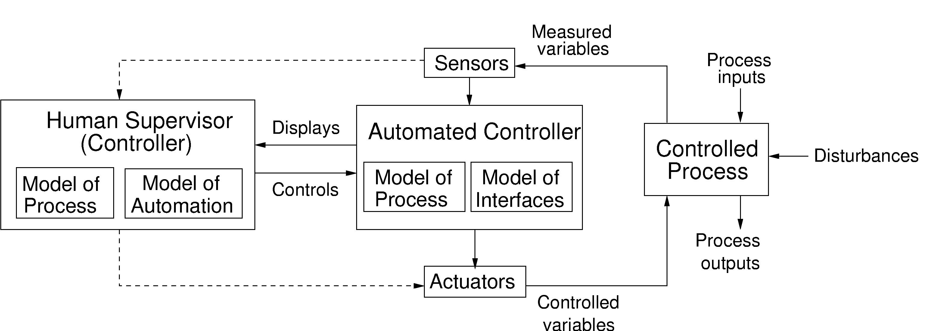

For effective control, the process models must contain the following: (1) the current state of the system being controlled, (2) the required relationship between system variables, and (3) the ways the process can change state. Accidents, particularly system accidents, frequently result from inconsistencies between the model of the process used by the controllers and the actual process state: for example, the lander software thinks the lander has reached the surface and shuts down the descent engine; the Minister of Health has received no reports about water quality problems and believes the state of water quality in the town is better than it actually is; or a mission manager believes that foam shedding is a maintenance or turnaround issue only. Part of our modeling efforts involve creating the process models, examining the ways that they can become inconsistent with the actual state (e.g., missing or incorrect feedback), and determining what feedback loops are necessary to maintain the safety constraints.
When there are multiple controllers and decision makers, system accidents may also involve inadequate control actions and unexpected side effects of decisions or actions, again often the result of inconsistent process models. For example, two controllers may both think the other is making the required control action (both Canadian government ministries responsible for the water supply and public health thought the other had followed up on the previous poor water quality reports), or they make control actions that conflict with each other. Communication plays an important role here: Accidents are most likely in the boundary or overlap areas where two or more controllers control the same process (Leplat, 1987).
A STAMP modeling and analysis effort involves creating a model of the system safety control structure: the safety requirements and constraints that each component (both technical and organizational) is responsible for maintaining; controls and feedback channels; process models representing the view of the controlled process by those controlling it; and a model of the dynamics and pressures that can lead to degradation of this structure over time. These models and the analysis procedures defined for them can be used (1) to investigate accidents and incidents to determine the role played by the different components of the safety control structure and learn how to prevent related accidents in the future, (2) to proactively perform hazard analysis and design to reduce risk throughout the life of the system, and (3) to support a continuous risk management program where risk is monitored and controlled.

STAMP-Based Hazard Analysis (STPA)

Current hazard analysis techniques, such as fault tree analysis, do not provide the power necessary to handle software-intensive systems, system accidents (whose roots lie in dysfunctional interactions among system components rather than individual component failures, such as occurred in the Columbia and Mars Polar Lander losses), and systems involving complex human-automation interaction and distributed decision-making. To handle these types of systems, which will be common in future space exploration and advanced aviation, more powerful hazard analysis techniques will be needed that include more than simply component failure as an accident cause. We have developed a new approach to hazard analysis, based on STAMP, called STPA (STamP Analysis) that handles hardware, software, human decision-making, and organizational factors in accidents.
STPA starts in the early concept development stages of a project and continues throughout the life of the system. Its use during system design supports a safety-driven design process where the hazard analysis influences and shapes the early system design decisions and then is iterated and refined as the design evolves and more information becomes available.
STPA has the same general goals as any hazard analysis: (1) identification of the system hazards and the related safety constraints necessary to ensure acceptable risk and (2) accumulation of information about how those hazards could be violated so it can be used in eliminating, reducing, and controlling hazards. Thus, the process starts with identifying the system requirements and design constraints necessary to maintain safety. In later steps, STPA assists in the top-down refinement of the safety-related system requirements and constraints into requirements and constraints on the individual system components. We note that this is exactly the process required in the new NASA Software Safety Standard NASA-STD-8719.13B. STPA provides a method to implement that new standard. The same approach can, of course, be applied to hardware and human activities, not just software. The overall STPA process provides the information and documentation necessary to ensure the safety constraints are enforced in system design, development, manufacturing, and operations.
In general, safety-driven design involves first attempting to eliminate hazards from the design and, if that is not possible or requires unacceptable tradeoffs, reducing the probability the hazard will occur, reducing the negative consequences of the hazard, and implementing contingency plans for dealing with the hazard. As design decisions are made, an STPA-based hazard analysis is used to inform those decisions.
STPA is used to identify the safety constraints that must be enforced, the control required to enforce those constraints, and the reasons the control may be enforced inadequately. That information is used to select designs and make design decisions at each step of the design process, starting with the early architectural trades and concept design. As the design is refined, the STPA analysis is refined in parallel in a step-by-step process. Control requirements that cannot be resolved in the design itself (either because of infeasibility or because it would require unacceptable tradeoffs with other goals) are then used as the basis for designing performance monitoring and safety management requirements during operations. An example application of STPA to the safety-driven design of a hypothetical industrial robot for inspection and waterproofing of the thermal tiles on the Space Shuttle can be found in Dulac and Leveson (2004).
A unique aspect of STPA is its dynamic nature. An effective hazard control approach at the beginning of a system lifecycle may become less effective at enforcing the safety constraints as the result of evolution of and changes to the system and eroding control mechanisms. Traditional hazard analysis techniques are static in nature, focusing on the ability of the system to avoid unsafe states given the current system design and its environment. In contrast, STPA assumes that systems are dynamic in nature and will evolve and adapt based on changes within the system and in the operating environment. A complete hazard analysis must therefore identify the possible changes in the safety controls over time that could lead to a high-risk state. System dynamics models can be used for this purpose. The information derived from the analysis can be used (1) to prevent such changes through system design or, if that is not possible, (2) to generate operational metrics and monitoring procedures to detect such degradation and (3) to design controls on maintenance, system changes, and upgrade activities.

Health Monitoring and Organizational Risk Management

When hazards cannot be totally eliminated from the design, some type of monitoring is often required to back up other types of hazard control in the system design. An infeasibly large number of parameters, however, can potentially be monitored by safety management systems in complex, human-machine systems. A major problem is to determine which parameters will detect errors that are likely to lead to human or mission loss. One way to accomplish this goal is to use the information obtained in the hazard analysis. STPA (and other hazard analysis techniques to a lesser extent, depending on what is being monitored) can provide this information. The use of STPA on physical systems was described above. A more unusual application is in the monitoring of the safety culture and organizational decision-making that can lead to unacceptable system risk. The rest of this paper describes an application of the new systems approach to organizational risk management.
This approach rests on the hypothesis that safety culture and organizational risk factors can be modeled, formally analyzed, and engineered. Models of the organizational safety control structure and dynamic decision-making and review processes can potentially be used for: (1) designing and validating improvements to the risk management and safety culture; (2) evaluating and analyzing organizational risk factors; (3) detecting when risk is increasing to unacceptable levels (a virtual “canary in the coal mine”); (4) evaluating the potential impact of changes and policy decisions on risk; (5) performing “root cause” analysis that identifies systemic factors and not just symptoms of the underlying organizational and culture problems; and (6) determining the information each decision-maker needs to manage risk effectively and the communication requirements for coordinated decision-making across large projects.
One of the advantages of using formal models in organizational and project risk analysis is that analytical tools can be used to identify the most important leading indicators of increasing system risk. Most major accidents do not result simply from a unique set of proximal, physical events but from the drift of the organization to a state of heightened risk over time as safeguards and controls are relaxed due to conflicting goals and tradeoffs. In this state, some events are bound to occur that will trigger an accident. In both the Challenger and Columbia losses, organizational risk had been increasing to unacceptable levels for quite some time as behavior and decision-making evolved in response to a variety of internal and external pressures. Because risk increased slowly, nobody noticed it, i.e., the “boiled frog” phenomenon. In fact, confidence and complacency were increasing at the same time as risk due to the lack of accidents.
The challenge in preventing accidents is to establish safeguards and metrics to prevent and detect migration to a state of unacceptable risk before an accident occurs. The process of tracking leading indicators of increasing risk (the virtual “canary in the coal mine”) can play an important role in preventing accidents. Note that our goal is not quantitative risk assessment, but rather to identify the factors involved in risk, their relationship to each other, and their impact on overall system risk.
This approach to risk management was developed during its application for the assessment of the new Independent Technical Authority program in the NASA Manned Space Program (Leveson et.al, 2005). It uses a traditional system engineering and System Safety approach but built on STAMP and STPA and adapted to the task at hand, i.e., organizational risk analysis. Figure 6 shows the overall process, which involves six steps:
- Perform a high-level system hazard analysis, i.e., identify the system-level hazards to be the focus of the analysis and then the system requirements and design constraints necessary to avoid those hazards.
- Create the STAMP hierarchical safety control structure using either the organizational design as it exists or creating a new design that satisfies the system requirements and constraints. This control structure will include the roles and responsibilities of each component with respect to safety.
- Identify any gaps in the control structure that might lead to a lack of fulfillment of the system safety requirements and design constraints and places where changes or enhancements in the control structure might be helpful.
- Use STPA to identify the inadequate controls for each of the control structure components that could lead to the component’s responsibilities not being fulfilled. These are the system risks.
- Categorize the risks as to whether they need to be assessed immediately or whether they are longer-term risks that require monitoring over time. Identify some potential metrics or measures of effectiveness for each of the risks.
- Create a system dynamics model of the non-linear dynamics of the system and use the models to identify the most important leading indicators of risk that need to be monitored during the lifetime of the system or program. Perform other types of analysis on the models to identify additional risk factors.

1. Preliminary Hazard Analysis |  | 2. Modeling the NASA Safety Control Structure |  | 3. Mapping Requirements to Responsibilities |  | 4. Detailed Hazard Analysis
- System hazards  - System safety requirements and constraints |  | - Roles and responsibilities  - Feedback mechanisms |  | - Gap analysis |  | - System risks (inadequate controls)
5. Categorizing & Analyzing Risks |  | 6. System Dynamics Modeling  and Analysis |  | 7. Findings and Recommendations
- Immediate and longer term risks |  | - Sensitivity  - Leading indicators  - Risk Factors |  | - Policy  - Structure  - Leading indicators and measures of effectiveness

Figure 6. The Process used in a STAMP-Based Organizational Risk Analysis

The first step in the risk analysis is a preliminary hazard analysis to identify the high-level hazard the system safety program must be designed to control and the general requirements and constraints necessary to eliminate that hazard. For NASA ITA that hazard is:

System Hazard: Poor engineering and management decision-making leading to an accident (loss)

From this hazard, high-level system requirements and constraints can be derived, for example:

System Safety Requirements and Constraints

1. Safety considerations must be first and foremost in technical decision-making.
- State-of-the art safety standards and requirements for NASA missions must be established, implemented, enforced, and maintained that protect the astronauts, the workforce, and the public.
- Safety-related technical decision-making must be independent from programmatic considerations, including cost and schedule.
- Safety-related decision-making must be based on correct, complete, and up-to-date information.
- Overall (final) decision-making must include transparent and explicit consideration of both safety and programmatic concerns.
- The Agency must provide for effective assessment and improvement in safety-related decision making.

- Safety-related technical decision-making must be done by eminently qualified experts, with broad participation of the full workforce.
- Technical decision-making must be credible (executed using credible personnel, technical requirements, and decision-making tools).
- Technical decision-making must be clear and unambiguous with respect to authority, responsibility, and accountability.
- All safety-related technical decisions, before being implemented by the Program, must have the approval of the technical decision-maker assigned responsibility for that class of decisions.
- Mechanisms and processes must be created that allow and encourage all employees and contractors to contribute to safety-related decision-making.

- Safety analyses must be available and used starting in the early acquisition, requirements development, and design processes and continuing through the system lifecycle.
- High-quality system hazard analyses must be created.
- Personnel must have the capability to produce high-quality safety analyses.
- Engineers and managers must be trained to use the results of hazard analyses in their decision-making.
- Adequate resources must be applied to the hazard analysis process.
- Hazard analysis results must be communicated in a timely manner to those who need them. A communication structure must be established that includes contractors and allows communication downward, upward, and sideways (e.g., among those building subsystems).
- Hazard analyses must be elaborated (refined and extended) and updated as the design evolves and test experience is acquired.
- During operations, hazard logs must be maintained and used as experience is acquired. All in-flight anomalies must be evaluated for their potential to contribute to hazards.

- The Agency must provide avenues for the full expression of technical conscience (for safety-related technical concerns) and provide a process for full and adequate resolution of technical conflicts as well as conflicts between programmatic and technical concerns.
- Communication channels, resolution processes, adjudication procedures must be created to handle expressions of technical conscience.
- Appeals channels must be established to surface complaints and concerns about aspects of the safety-related decision making and technical conscience structures that are not functioning appropriately.

The next step is to create a model of a safety control structure, in this case the NASA manned space program. This model includes the roles and responsibilities of each organizational component with respect to safety. Each of the above system safety requirements and constraints is then traced to those components responsible for their implementation and enforcement. This process may identify omissions in the organizational design and places where overlapping control responsibilities could lead to conflicts or require careful coordination and communication.
The fourth step is to perform a hazard analysis on the safety control structure, using STPA. As noted above, STPA works on both the technical (physical) and the organizational (social) aspects of systems. There are four general types of risks of ITA:
- Unsafe decisions are made by or approved by the ITA warrant holders.
- Safe decisions are disallowed (i.e., overly conservative decision-making that undermines the goals of NASA and long-term support for ITA);
- Decision-making takes too long, minimizing impact and also reducing support for ITA.
- Good decisions are made by ITA, but they do not have adequate impact on system design, construction, and operation.
The hazard analysis applied each of these types of risks to the NASA organizational components and functions involved in safety-related decision-making and identified the risks (inadequate controls) associated with each. For example, one responsibility of the NASA Chief Engineer is to develop, monitor, and maintain the NASA technical standards and policy. The risks associated with this responsibility are:
- General technical and safety standards and policy are not created.
- Inadequate standards are created.
- The standards degrade as they are changed over time due to external pressures to weaken them (as happened before the Columbia accident). The process for approving changes is flawed.
- The standards are not changed or updated over time as the environment changes.
The resulting list of risks is quite long (250), but most appear to be important and not easily dismissed. To reduce the list to one that can be feasibly assessed, we categorize each risk as either an immediate and substantial concern, a longer-term concern, or capable of being handled through standard processes and not needing a special assessment.
The next step in the risk analysis process is to create a system dynamics model, in this case a model of the NASA manned space program. Figure 5 shows a greatly simplified example; the model we used in the ITA risk analysis had several hundred variables and consists of nine sub-models related to safety-culture and system safety engineering: Risk; Perceived Success by Administration; System Safety Resource Allocation; System Safety Efforts and Efficacy; Incident Learning and Corrective Action; Vehicle Aging and Maintenance; System Safety Knowledge, Skills, and Staffing; Launch Rate, and Independent Technical Authority. Because of the size of the complete model, the individual sub-models were first validated separately and then put together.
In the final step, the system dynamics model is used to identify which risks are the most important to measure and assess, i.e., which provide the best measure of the current level of organizational risk and are the most likely to detect increasing risk early enough to prevent significant losses. This analysis led to a list of the best leading indicators of increasing and unacceptable risk in the manned space program The analysis also identified important structural changes to the current NASA safety control structure and planned evolution of the safety-related decision-making structure over time that could strengthen the efforts to avoid migration to unacceptable levels of organizational risk and avoid flawed management and engineering decision-making leading to an accident. Some examples of the results of the risk analysis follow.

Impact of the ITA on Risk
The ITA program was introduced in response to a CAIB recommendation and is intended to be a major contributor to maintaining acceptable risk in the manned space program. We found that the introduction of ITA has the potential to significantly reduce risk and to sustain an acceptable risk level, countering some of the natural tendency for risk to increase over time due to complacency generated by success, aging vehicles and infrastructures, etc. However, we also found significant risk of unsuccessful implementation of ITA, leading to a migration toward states of unacceptable high risk.
In order to investigate the effect of ITA parameters on the system-level dynamics, a 200-run Monte-Carlo sensitivity analysis was performed. Random variations representing +/- 30% of the baseline ITA exogenous parameter values were used in the analysis. Figures 7 and 8 show the results.
The initial sensitivity analysis identified two qualitatively different behavior modes: 75% of the simulation runs showed a successful ITA program implementation where risk is adequately mitigated for a relatively long period of time (labeled “1” in Figures 7 and 8); the other runs identified a behavior mode with an initial rapid rise in effectiveness and then a collapse into an unsuccessful ITA program implementation where risk increases rapidly and accidents occur (labeled “2”).

Figure 7: Sensitivity Analysis Trace of ITA Effectiveness and Credibility

Figure 8: Sensitivity Analysis Trace of System Technical Risk

The ITA support structure is self-sustaining in both behavior modes for a short period of time if the conditions are in place for its early acceptance. This early behavior is representative of an initial excitement phase when ITA is implemented and shows great promise to reduce the level of risk. This short-term reinforcing loop provides the foundation for a solid, sustainable ITA program and safety control structure for the manned space program under the right conditions.
Even in the successful scenarios, after a period of very high success, the effectiveness and credibility of the ITA slowly starts to decline, mainly due to the effects of complacency where the safety efforts start to erode as the program is highly successful and safety is increasingly seen as a solved problem. When this decline occurs, resources are reallocated to more urgent performance-related matters. However, in the successful implementations, risk is still at acceptable levels, and an extended period of nearly steady-state equilibrium ensues where risk remains at low levels.
In the unsuccessful ITA implementation scenarios, effectiveness and credibility of the ITA quickly starts to decline after the initial increase and eventually reaches unacceptable levels. Conditions arise that limit the ability of ITA to have a sustained effect on the system. Hazardous events start to occur and safety is increasingly perceived as an urgent problem. More resources are allocated to safety efforts, but at this point the Technical Authority (TA) and the Technical Warrant Holders (TWHs) have lost so much credibility they are no longer able to significantly contribute to risk mitigation anymore. As a result, risk increases dramatically, the ITA personnel and the Safety and Mission Assurance staff become overwhelmed with safety problems and an increasing number of waivers are approved in order to continue flying.
As the number of problems identified increases along with their investigation requirements, corners may be cut to compensate, resulting in lower-quality investigation resolutions and corrective actions. If investigation requirements continue to increase, TWHs and Trusted Agents become saturated and simply cannot attend to each investigation in a timely manner. A bottleneck effect is created by requiring the TWHs to authorize all safety-related decisions, making things worse. Examining the factors in these unsuccessful scenarios can assist in making changes to the program to prevent them and, if that is not possible or desirable, to identify leading indicator metrics to detect rising risk while effective interventions are still possible and not overly costly in terms of resources and downtime.

Leading Indicators of Increasing Risk:
Results from a metrics analysis using our system dynamics model show that many model variables may provide good indications of risk. However, many of these indicators will only show an increase in risk after it has happened, limiting their role in preventing accidents. For example, the number of waivers issued over time is a good indicator of increasing risk, but its effectiveness is limited by the fact that waivers start to accumulate after risk has started to increase rapidly (see Figure 9).
System Technical Risk
Outstanding Accumulated Waivers

Figure 9. Example Lagging Indicator – Outstanding Accumulated Waivers
Other lagging indicators include the amount of resources available for safety activities; the schedule pressure, which will only be reduced when managers believe the system to be unsafe; and the perception of the risk level by management, which is primarily affected by events such as accidents and close-calls. Figure 10 shows an example of a leading indicator.
Finding leading indicators that can be used to monitor the program and detect increasing risk early is extremely important because of the dynamics associated with the non-linear tipping point associated with technical risk level. At this tipping point, risk increases slowly at first and then very rapidly (i.e., the reinforcing loop has a gain < 1). The system can be prevented from reaching this point, but once it is reached multiple serious problems occur rapidly and overwhelm the problem-solving capacity of ITA and the program management. When the system reaches that state, risk starts to increase rapidly, and a great deal of effort and resources will be necessary to bring the risk level down to acceptable levels.

System Technical Risk
Incidents Under Investigation

Figure 10. Example Leading Indicator – Incidents Under Investigation

The modeling and analysis identified five leading indicators of increasing and unacceptable risk levels in the NASA Manned Space Program that should be tracked: (1) Knowledge, skills, and quality of the TWHs, Trusted Agents, and safety staff (e.g., experience, technical knowledge, communication skills, reputation, social network, communication skills, difficulty in recruiting replacements, and amount of training); (2) investigation activity (fraction of problem reports under investigation, number of unresolved or unhandled problems); (3) quality of the safety analyses (knowledge and skills of analysis staff, resources applied to analyses, availability of lessons learned); (4) quality of incident (hazardous event and anomaly) investigation (number and quality of those involved, resources and workload, independence and work balance, systemic factor fixes vs. symptom removal); and (5) power and authority of the Trusted Agents and Technical Warrant Holders.

Conclusions

While the reliability and system safety engineering approaches developed after World War II have served us well for a long time, technology and complexity is starting to overwhelm their capabilities. This paper has distinguished the approaches of Reliability Engineering and System Safety in building safe and reliable systems and described their limitations. A new approach, based on systems theory, has the potential to overcome these limitations and is being proven on a wide variety of industrial applications. The new approach has the advantage of not only applying to new types of technology but also extending the boundaries of traditional risk and hazard analysis to the social and organizational aspects of systems considered in the large.

References

Charles Billings (1996). Aviation Automation: The Search for a Human-Centered Approach, Lawrence Erlbaum Associates, New York.

J.H. Cooper (1891). “Accident-prevention devices applied to machines,” Transactions of the ASME, 12:249-264.

Nicolas Dulac and Nancy Leveson (2004). “An Approach to Design for Safety in Complex Systems,” International Symposium on Systems Engineering (INCOSE ‘04), Toulouse France, June.

Jay W. Forrester (1961). Industrial Dynamics, Pegasus Communications.

Jerome Lederer (1986). “How far have we come? A look back a the leading edge of system safety eighteen years ago.” Hazard Prevention, page 8, May/June.

Jacques Leplat (1987). Occupational Accident Research and Systems Approach. In Jens Rasmussen, Keith Duncan, and Jacques Leplat (editors), New Technology and Human Error, pp. 181-191, New York: John Wiley & Sons.

Nancy Leveson (1995). Safeware, Reading, MA: Addison-Wesley Publishing Company.

Nancy Leveson (2005). A New Approach to System Safety Engineering, incomplete draft (downloadable from http://sunnyday.mit.edu/book2.html)

Nancy Leveson, Nicolas Dulac, Betty Barrett, John Carroll, Joel Cutcher-Gershenfeld, Stephen Friedenthal (2005). Risk Analysis of NASA Independent Technical Authority, July, http://sunnyday.mit.edu/ITA-Risk-Analysis.doc.

C.O. Miller (1985). “A comparison of military and civil approaches to aviation system safety, Hazard Prevention, pages 29-34, May/June.

Charles Perrow (1984). Normal Accidents, Basic Books (reprinted in 19XX by XXX University Press).

Jens Rasmussen (1997). “Risk management in a dynamic society: A modeling problem,” Safety Science, Vol. 27, No. 2/3, Elsevier Science Ltd., pp. 183-213.

Jens Rasmussen and Inge Svedung (2000). Proactive Risk Management in a Dynamic Society, Swedish Rescue Services Agency.

Peter Senge (1990). The Fifth Discipline: The Art and Practice of Learning Organizations. Doubleday Currency, New York.

John Sterman (2000). Business Dynamics: Systems Thinking and Modeling for a Complex World, McGraw-Hill, New York.

This paper is a draft paper for the NASA Ames Integrated System Health Engineering and Management Forum, November 2005. The research reported in the paper was partly supported by the Center for Program/Project Management of the USRA and by various NASA programs, particularly Engineering for Complex Systems.

